Output Lisrel -- Model CFA

- Model CFA Job Insecurity (JI)
  - Afektif
Model CFA awal:
Output Gambar Loading Faktor
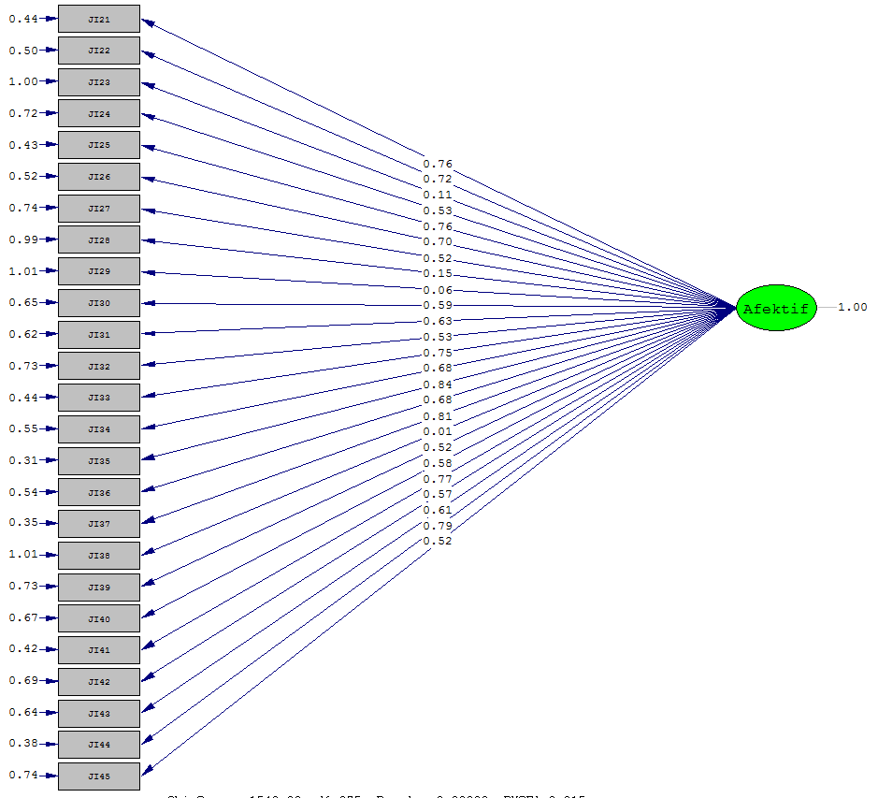

Output tulisan:
Model CFA_JIafektifAwal

Number of Iterations = 22

LISREL Estimates (Maximum Likelihood)

Measurement Equations

JI21 = 0.757*Afektif, Errorvar.= 0.436 , R² = 0.568
Standerr (0.0870) (0.0668)
Z-values 8.703 6.527
P-values 0.000 0.000

JI22 = 0.717*Afektif, Errorvar.= 0.496 , R² = 0.509
Standerr (0.0889) (0.0748)
Z-values 8.061 6.635
P-values 0.000 0.000

JI23 = 0.107*Afektif, Errorvar.= 0.999 , R² = 0.0113
Standerr (0.103) (0.142)
Z-values 1.034 7.031
P-values 0.301 0.000

JI24 = 0.531*Afektif, Errorvar.= 0.718 , R² = 0.184
Standerr (0.0986) (0.119)
Z-values 4.365 6.949
P-values 0.000 0.000

JI25 = 0.763*Afektif, Errorvar.= 0.428 , R² = 0.576
Standerr (0.0868) (0.0658)
Z-values 8.788 6.510
P-values 0.000 0.000

JI26 = 0.702*Afektif, Errorvar.= 0.517 , R² = 0.488
Standerr (0.0896) (0.0776)
Z-values 7.834 6.668
P-values 0.000 0.000

JI27 = 0.516*Afektif, Errorvar.= 0.744 , R² = 0.264
Standerr (0.0963) (0.108)
Z-values 5.358 6.897
P-values 0.000 0.000

JI28 = 0.148*Afektif, Errorvar.= 0.988 , R² = 0.0217
Standerr (0.103) (0.141)
Z-values 1.437 7.027
P-values 0.151 0.000

JI29 = 0.0641*Afektif, Errorvar.= 1.006 , R² = 0.00407
Standerr (0.104) (0.143)
Z-values 0.619 7.034
P-values 0.536 0.000

JI30 = 0.594*Afektif, Errorvar.= 0.647 , R² = 0.153
Standerr (0.0995) (0.123)
Z-values 3.956 6.966
P-values 0.000 0.000

JI31 = 0.627*Afektif, Errorvar.= 0.617 , R² = 0.390
Standerr (0.0926) (0.0908)
Z-values 6.773 6.789
P-values 0.000 0.000

JI32 = 0.525*Afektif, Errorvar.= 0.734 , R² = 0.273
Standerr (0.0961) (0.107)
Z-values 5.471 6.890
P-values 0.000 0.000

JI33 = 0.753*Afektif, Errorvar.= 0.443 , R² = 0.561
Standerr (0.0873) (0.0677)
Z-values 8.629 6.541
P-values 0.000 0.000

JI34 = 0.675*Afektif, Errorvar.= 0.554 , R² = 0.451
Standerr (0.0907) (0.0825)
Z-values 7.442 6.718
P-values 0.000 0.000

JI35 = 0.838*Afektif, Errorvar.= 0.308 , R² = 0.695
Standerr (0.0829) (0.0501)
Z-values 10.107 6.154
P-values 0.000 0.000

JI36 = 0.683*Afektif, Errorvar.= 0.544 , R² = 0.462
Standerr (0.0904) (0.0811)
Z-values 7.553 6.704
P-values 0.000 0.000

JI37 = 0.811*Afektif, Errorvar.= 0.352 , R² = 0.651
Standerr (0.0843) (0.0558)
Z-values 9.616 6.313
P-values 0.000 0.000

JI38 = 0.00590*Afektif, Errorvar.= 1.010 , R² = 0.000
Standerr (0.104) (0.144)
Z-values 0.0569 7.036
P-values 0.955 0.000

JI39 = 0.518*Afektif, Errorvar.= 0.732 , R² = 0.0469
Standerr (0.102) (0.137)
Z-values 2.124 7.017
P-values 0.034 0.000

JI40 = 0.576*Afektif, Errorvar.= 0.668 , R² = 0.140
Standerr (0.0999) (0.125)
Z-values 3.759 6.973
P-values 0.000 0.000

JI41 = 0.766*Afektif, Errorvar.= 0.423 , R² = 0.582
Standerr (0.0866) (0.0650)
Z-values 8.850 6.498
P-values 0.000 0.000

JI42 = 0.568*Afektif, Errorvar.= 0.688 , R² = 0.319
Standerr (0.0947) (0.100)
Z-values 5.994 6.855
P-values 0.000 0.000

JI43 = 0.606*Afektif, Errorvar.= 0.642 , R² = 0.364
Standerr (0.0934) (0.0943)
Z-values 6.494 6.815
P-values 0.000 0.000

JI44 = 0.793*Afektif, Errorvar.= 0.381 , R² = 0.623
Standerr (0.0853) (0.0595)
Z-values 9.304 6.396
P-values 0.000 0.000

JI45 = 0.520*Afektif, Errorvar.= 0.740 , R² = 0.267
Standerr (0.0962) (0.107)
Z-values 5.401 6.895
P-values 0.000 0.000

Correlation Matrix of Independent Variables

Afektif
--------
1.000

Log-likelihood Values

Estimated Model Saturated Model
--------------- ---------------
Number of free parameters(t) 50 325
-2ln(L) 1612.655 64.561
AIC (Akaike, 1974)* 1712.655 714.561
BIC (Schwarz, 1978)* 1842.914 1561.242

*LISREL uses AIC= 2t - 2ln(L) and BIC = tln(N)- 2ln(L)

Goodness-of-Fit Statistics

Degrees of Freedom for (C1)-(C2) 189
Maximum Likelihood Ratio Chi-Square (C1) 1110.730 (P = 0.0000)
Browne's (1984) ADF Chi-Square (C2_NT) 1047.096 (P = 0.0000)

Estimated Non-centrality Parameter (NCP) 921.730
90 Percent Confidence Interval for NCP (820.562 ; 1030.380)

Minimum Fit Function Value 11.107
Population Discrepancy Function Value (F0) 9.217
90 Percent Confidence Interval for F0 (8.206 ; 10.304)
Root Mean Square Error of Approximation (RMSEA) 0.221
90 Percent Confidence Interval for RMSEA (0.208 ; 0.233)
P-Value for Test of Close Fit (RMSEA < 0.05) 0.000

Expected Cross-Validation Index (ECVI) 11.947
90 Percent Confidence Interval for ECVI (10.936 ; 13.034)
ECVI for Saturated Model 4.620
ECVI for Independence Model 20.777

Chi-Square for Independence Model (210 df) 2035.717

Normed Fit Index (NFI) 0.454
Non-Normed Fit Index (NNFI) 0.439
Parsimony Normed Fit Index (PNFI) 0.409
Comparative Fit Index (CFI) 0.495
Incremental Fit Index (IFI) 0.501
Relative Fit Index (RFI) 0.394

Critical N (CN) 22.137

Root Mean Square Residual (RMR) 0.124
Standardized RMR 0.124
Goodness of Fit Index (GFI) 0.501
Adjusted Goodness of Fit Index (AGFI) 0.390
Parsimony Goodness of Fit Index (PGFI) 0.410

Model CFA valid semua:
Output gambar loading faktor

Output tulisan:
Model CFA_JIafektifvalid

Number of Iterations = 24

LISREL Estimates (Maximum Likelihood)

Measurement Equations

JI21 = 0.859*Afektif, Errorvar.= 0.262 , R² = 0.576
Standerr (0.0863) (0.0650)
Z-values 8.795 6.521
P-values 0.000 0.000

JI22 = 0.814*Afektif, Errorvar.= 0.337 , R² = 0.510
Standerr (0.0884) (0.0737)
Z-values 8.082 6.641
P-values 0.000 0.000

JI24 = 0.522*Afektif, Errorvar.= 0.726 , R² = 0.178
Standerr (0.0983) (0.118)
Z-values 4.295 6.954
P-values 0.000 0.000

JI25 = 0.767*Afektif, Errorvar.= 0.412 , R² = 0.588
Standerr (0.0859) (0.0634)
Z-values 8.929 6.494
P-values 0.000 0.000

JI26 = 0.703*Afektif, Errorvar.= 0.506 , R² = 0.494
Standerr (0.0889) (0.0759)
Z-values 7.907 6.666
P-values 0.000 0.000

JI27 = 0.509*Afektif, Errorvar.= 0.741 , R² = 0.259
Standerr (0.0960) (0.107)
Z-values 5.300 6.904
P-values 0.000 0.000

JI30 = 0.593*Afektif, Errorvar.= 0.648 , R² = 0.154
Standerr (0.0989) (0.121)
Z-values 3.968 6.967
P-values 0.000 0.000

JI31 = 0.729*Afektif, Errorvar.= 0.469 , R² = 0.396
Standerr (0.0919) (0.0890)
Z-values 6.843 6.788
P-values 0.000 0.000

JI32 = 0.532*Afektif, Errorvar.= 0.717 , R² = 0.283
Standerr (0.0952) (0.104)
Z-values 5.590 6.886
P-values 0.000 0.000

JI33 = 0.756*Afektif, Errorvar.= 0.428 , R² = 0.572
Standerr (0.0864) (0.0655)
Z-values 8.750 6.530
P-values 0.000 0.000

JI34 = 0.676*Afektif, Errorvar.= 0.543 , R² = 0.457
Standerr (0.0901) (0.0809)
Z-values 7.505 6.718
P-values 0.000 0.000

JI35 = 0.935*Afektif, Errorvar.= 0.126, R² = 0.698
Standerr (0.0823) (0.0491)
Z-values 10.144 6.161
P-values 0.000 0.000

JI36 = 0.686*Afektif, Errorvar.= 0.529 , R² = 0.471
Standerr (0.0896) (0.0790)
Z-values 7.653 6.700
P-values 0.000 0.000

JI37 = 0.912*Afektif, Errorvar.= 0.168 , R² = 0.660
Standerr (0.0836) (0.0540)
Z-values 9.716 6.301
P-values 0.000 0.000

JI39 = 0.511*Afektif, Errorvar.= 0.739, R² = 0.0445
Standerr 0.102) (0.136)
Z-values 2.070 7.018
P-values 0.038 0.000

JI40 = 0.571*Afektif, Errorvar.= 0.674 , R² = 0.138
Standerr (0.0994) (0.124)
Z-values 3.734 6.975
P-values 0.000 0.000

JI41 = 0.770*Afektif, Errorvar.= 0.407 , R² = 0.593
Standerr (0.0858) (0.0627)
Z-values 8.983 6.483
P-values 0.000 0.000

JI42 = 0.562*Afektif, Errorvar.= 0.684 , R² = 0.316
Standerr (0.0943) (0.0997)
Z-values 5.964 6.861
P-values 0.000 0.000

JI43 = 0.605*Afektif, Errorvar.= 0.634 , R² = 0.366
Standerr (0.0928) (0.0930)
Z-values 6.517 6.818
P-values 0.000 0.000

JI44 = 0.889*Afektif, Errorvar.= 0.209 , R² = 0.623
Standerr (0.0848) (0.0588)
Z-values 9.310 6.409
P-values 0.000 0.000

JI45 = 0.518*Afektif, Errorvar.= 0.732 , R² = 0.268
Standerr (0.0957) (0.106)
Z-values 5.411 6.897
P-values 0.000 0.000

Correlation Matrix of Independent Variables

Afektif
--------
1.000

Log-likelihood Values

Estimated Model Saturated Model
--------------- ---------------
Number of free parameters(t) 42 231
-2ln(L) 1175.012 64.283
AIC (Akaike, 1974)* 1259.012 526.283
BIC (Schwarz, 1978)* 1368.429 1128.077

*LISREL uses AIC= 2t - 2ln(L) and BIC = tln(N)- 2ln(L)

Goodness-of-Fit Statistics

Degrees of Freedom for (C1)-(C2) 94
Maximum Likelihood Ratio Chi-Square (C1) 392.02 (P = 0.0000)
Browne's (1984) ADF Chi-Square (C2_NT) 347.09 (P = 0.0000)

Estimated Non-centrality Parameter (NCP) 221.730
90 Percent Confidence Interval for NCP (182.562 ; 330.380)

Minimum Fit Function Value 11.107
Population Discrepancy Function Value (F0) 9.217
90 Percent Confidence Interval for F0 (8.206 ; 10.304)
Root Mean Square Error of Approximation (RMSEA) 0.221
90 Percent Confidence Interval for RMSEA (0.208 ; 0.233)
P-Value for Test of Close Fit (RMSEA < 0.05) 0.000

Expected Cross-Validation Index (ECVI) 11.947
90 Percent Confidence Interval for ECVI (10.936 ; 13.034)
ECVI for Saturated Model 4.620
ECVI for Independence Model 20.777

Chi-Square for Independence Model (210 df) 1035.717

Normed Fit Index (NFI) 0.854
Non-Normed Fit Index (NNFI) 0.839
Parsimony Normed Fit Index (PNFI) 0.809
Comparative Fit Index (CFI) 0.895
Incremental Fit Index (IFI) 0.901
Relative Fit Index (RFI) 0.794

Critical N (CN) 22.137

Root Mean Square Residual (RMR) 0.019
Standardized RMR 0.019
Goodness of Fit Index (GFI) 0.901
Adjusted Goodness of Fit Index (AGFI) 0.890
Parsimony Goodness of Fit Index (PGFI) 0.910

  - Kognitif
Model CFA Awal:
Output Gambar Nilai Loading Faktor
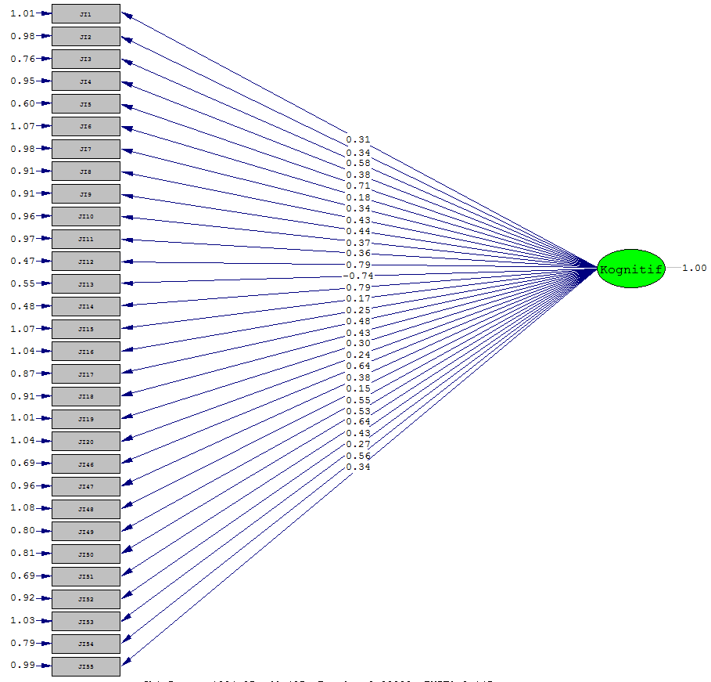

Output Tulisan:
Model CFA_JIkognitifAwal

Number of Iterations = 28

LISREL Estimates (Maximum Likelihood)

Measurement Equations

JI1 = 0.308*Kognitif, Errorvar.= 1.005 , R² = 0.0861
Standerr (0.108) (0.144)
Z-values 2.845 6.967
P-values 0.004 0.000

JI2 = 0.340*Kognitif, Errorvar.= 0.984 , R² = 0.105
Standerr (0.108) (0.142)
Z-values 3.163 6.950
P-values 0.002 0.000

JI3 = 0.582*Kognitif, Errorvar.= 0.761 , R² = 0.308
Standerr (0.101) (0.113)
Z-values 5.748 6.711
P-values 0.000 0.000

JI4 = 0.382*Kognitif, Errorvar.= 0.954 , R² = 0.132
Standerr (0.107) (0.138)
Z-values 3.574 6.924
P-values 0.000 0.000

JI5 = 0.708*Kognitif, Errorvar.= 0.598 , R² = 0.456
Standerr (0.0964) (0.0932)
Z-values 7.344 6.423
P-values 0.000 0.000

JI6 = 0.183*Kognitif, Errorvar.= 1.066 , R² = 0.0306
Standerr (0.110) (0.152)
Z-values 1.670 7.013
P-values 0.095 0.000

JI7 = 0.344*Kognitif, Errorvar.= 0.982 , R² = 0.107
Standerr (0.108) (0.141)
Z-values 3.195 6.948
P-values 0.001 0.000

JI8 = 0.433*Kognitif, Errorvar.= 0.913 , R² = 0.170
Standerr (0.106) (0.133)
Z-values 4.097 6.886
P-values 0.000 0.000

JI9 = 0.440*Kognitif, Errorvar.= 0.907 , R² = 0.176
Standerr (0.105) (0.132)
Z-values 4.169 6.880
P-values 0.000 0.000

JI10 = 0.367*Kognitif, Errorvar.= 0.965 , R² = 0.123
Standerr (0.107) (0.139)
Z-values 3.432 6.934
P-values 0.001 0.000

JI11 = 0.360*Kognitif, Errorvar.= 0.970 , R² = 0.118
Standerr (0.107) (0.140)
Z-values 3.359 6.938
P-values 0.001 0.000

JI12 = 0.791*Kognitif, Errorvar.= 0.474 , R² = 0.569
Standerr (0.0926) (0.0781)
Z-values 8.546 6.069
P-values 0.000 0.000

JI13 = 0.743*Kognitif, Errorvar.= 0.548 , R² = 0.501
Standerr (0.0949) (0.0870)
Z-values 7.826 6.300
P-values 0.000 0.000

JI14 = 0.785*Kognitif, Errorvar.= 0.484 , R² = 0.560
Standerr (0.0929) (0.0792)
Z-values 8.453 6.103
P-values 0.000 0.000

JI15 = 0.174*Kognitif, Errorvar.= 1.070 , R² = 0.0276
Standerr (0.110) (0.152)
Z-values 1.585 7.015
P-values 0.113 0.000

JI16 = 0.248*Kognitif, Errorvar.= 1.039 , R² = 0.0558
Standerr (0.109) (0.149)
Z-values 2.271 6.993
P-values 0.023 0.000

JI17 = 0.484*Kognitif, Errorvar.= 0.865 , R² = 0.213
Standerr (0.104) (0.127)
Z-values 4.645 6.838
P-values 0.000 0.000

JI18 = 0.433*Kognitif, Errorvar.= 0.912 , R² = 0.171
Standerr (0.106) (0.132)
Z-values 4.104 6.886
P-values 0.000 0.000

JI19 = 0.304*Kognitif, Errorvar.= 1.008 , R² = 0.0839
Standerr (0.108) (0.145)
Z-values 2.807 6.969
P-values 0.005 0.000

JI20 = 0.235*Kognitif, Errorvar.= 1.045 , R² = 0.0503
Standerr (0.109) (0.149)
Z-values 2.153 6.997
P-values 0.031 0.000

JI46 = 0.638*Kognitif, Errorvar.= 0.692 , R² = 0.371
Standerr (0.0992) (0.105)
Z-values 6.433 6.606
P-values 0.000 0.000

JI47 = 0.380*Kognitif, Errorvar.= 0.955 , R² = 0.131
Standerr (0.107) (0.138)
Z-values 3.561 6.925
P-values 0.000 0.000

JI48 = 0.151*Kognitif, Errorvar.= 1.077 , R² = 0.0208
Standerr (0.110) (0.153)
Zvalues 1.375 7.020
Pvalues 0.169 0.000

JI49 = 0.550*Kognitif, Errorvar.= 0.797 , R² = 0.275
Standerr (0.102) (0.118)
Zvalues 5.378 6.759
Pvalues 0.000 0.000

JI50 = 0.535*Kognitif, Errorvar.= 0.814 , R² = 0.260
Standerr (0.103) (0.120)
Zvalues 5.199 6.780
Pvalues 0.000 0.000

JI51 = 0.637*Kognitif, Errorvar.= 0.694 , R² = 0.369
Standerr (0.0993) (0.105)
Zvalues 6.421 6.608
Pvalues 0.000 0.000

JI52 = 0.429*Kognitif, Errorvar.= 0.916 , R² = 0.167
Standerr (0.106) (0.133)
Zvalues 4.055 6.889
Pvalues 0.000 0.000

JI53 = 0.267*Kognitif, Errorvar.= 1.029 , R² = 0.0647
Standerr (0.109) (0.147)
Zvalues 2.452 6.985
P-values 0.014 0.000

JI54 = 0.559*Kognitif, Errorvar.= 0.787 , R² = 0.285
Standerr (0.102) (0.117)
Zvalues 5.484 6.746
Pvalues 0.000 0.000

JI55 = 0.337*Kognitif, Errorvar.= 0.987 , R² = 0.103
Standerr (0.108) (0.142)
Zvalues 3.127 6.952
Pvalues 0.002 0.000

Correlation Matrix of Independent Variables

Kognitif
--------
1.000

Log-likelihood Values

Estimated Model Saturated Model
--------------- ---------------
Number of free parameters(t) 60 465
-2ln(L) 2771.153 1486.898
AIC (Akaike, 1974)* 2891.153 2416.898
BIC (Schwarz, 1978)* 3047.464 3628.303

*LISREL uses AIC= 2t - 2ln(L) and BIC = tln(N)- 2ln(L)

Goodness-of-Fit Statistics

Degrees of Freedom for (C1)-(C2) 324
Maximum Likelihood Ratio Chi-Square (C1) 1076.276 (P = 0.0000)
Browne's (1984) ADF Chi-Square (C2_NT) 1219.933 (P = 0.0000)

Estimated Non-centrality Parameter (NCP) 752.276
90 Percent Confidence Interval for NCP (656.560 ; 855.575)

Minimum Fit Function Value 10.763
Population Discrepancy Function Value (F0) 7.523
90 Percent Confidence Interval for F0 (6.566 ; 8.556)
Root Mean Square Error of Approximation (RMSEA) 0.078
90 Percent Confidence Interval for RMSEA (0.042 ; 0.093)
P-Value for Test of Close Fit (RMSEA < 0.05) 0.000

Expected Cross-Validation Index (ECVI) 11.843
90 Percent Confidence Interval for ECVI (10.886 ; 12.876)
ECVI for Saturated Model 7.560
ECVI for Independence Model 16.377

Chi-Square for Independence Model (351 df) 1583.745

Normed Fit Index (NFI) 0.320
Non-Normed Fit Index (NNFI) 0.339
Parsimony Normed Fit Index (PNFI) 0.296
Comparative Fit Index (CFI) 0.390
Incremental Fit Index (IFI) 0.403
Relative Fit Index (RFI) 0.264

Critical N (CN) 36.519

Root Mean Square Residual (RMR) 0.154
Standardized RMR 0.140
Goodness of Fit Index (GFI) 0.525
Adjusted Goodness of Fit Index (AGFI) 0.446
Parsimony Goodness of Fit Index (PGFI) 0.450

Model CFA Valid semua:
Output Gambar nilai Loading Faktor
Output tulisan:
Model CFA_JIkognitifValid

Number of Iterations = 26

LISREL Estimates (Maximum Likelihood)

Measurement Equations

JI1 = 0.508*Kognitif, Errorvar.= 0.742, R² = 0.0862
Standerr (0.108) (0.144)
Z-values 2.845 6.966
P-values 0.004 0.000

JI2 = 0.536*Kognitif, Errorvar.= 0.713 , R² = 0.103
Standerr (0.108) (0.142)
Z-values 3.122 6.951
P-values 0.002 0.000

JI3 = 0.779*Kognitif, Errorvar.= 0.393 , R² = 0.305
Standerr (0.101) (0.114)
Z-values 5.709 6.713
P-values 0.000 0.000

JI4 = 0.578*Kognitif, Errorvar.= 0.666 , R² = 0.130
Standerr (0.107) (0.138)
Z-values 3.538 6.926
P-values 0.000 0.000

JI5 = 0.913*Kognitif, Errorvar.= 0.166 , R² = 0.462
Standerr (0.0963) (0.0924)
Z-values 7.409 6.401
P-values 0.000 0.000

JI7 = 0.545*Kognitif, Errorvar.= 0.703 , R² = 0.108
Standerr (0.108) (0.141)
Z-values 3.206 6.947
P-values 0.001 0.000

JI8 = 0.535*Kognitif, Errorvar.= 0.714 , R² = 0.172
Standerr (0.106) (0.132)
Z-values 4.119 6.883
P-values 0.000 0.000

JI9 = 0.538*Kognitif, Errorvar.= 0.711 , R² = 0.175
Standerr (0.106) (0.132)
Z-values 4.152 6.880
P-values 0.000 0.000

JI10 = 0.567*Kognitif, Errorvar.= 0.679 , R² = 0.123
Standerr (0.107) (0.139)
Z-values 3.428 6.933
P-values 0.001 0.000

JI11 = 0.559*Kognitif, Errorvar.= 0.688 , R² = 0.117
Standerr (0.107) (0.140)
Z-values 3.344 6.938
P-values 0.001 0.000

JI12 = 0.992*Kognitif, Errorvar.= 0.016 , R² = 0.571
Standerr (0.0926) (0.0780)
Z-values 8.559 6.054
P-values 0.000 0.000

JI13 = 0.942*Kognitif, Errorvar.= 0.113 , R² = 0.500
Standerr (0.0950) (0.0873)
Z-values 7.811 6.297
P-values 0.000 0.000

JI14 = 0.981*Kognitif, Errorvar.= 0.038 , R² = 0.555
Standerr (0.0931) (0.0801)
Z-values 8.388 6.116
P-values 0.000 0.000

JI16 = 0.544*Kognitif, Errorvar.= 0.704, R² = 0.0541
Standerr (0.109) (0.149)
Z-values 2.234 6.994
P-values 0.025 0.000

JI17 = 0.585*Kognitif, Errorvar.= 0.656 , R² = 0.214
Standerr (0.104) (0.126)
Z-values 4.655 6.835
P-values 0.000 0.000

JI18 = 0.534*Kognitif, Errorvar.= 0.715 , R² = 0.171
Standerr (0.106) (0.132)
Z-values 4.111 6.884
P-values 0.000 0.000

JI19 = 0.508*Kognitif, Errorvar.= 0.742, R² = 0.0863
Standerr (0.108) (0.144)
Z-values 2.848 6.966
P-values 0.004 0.000

JI20 = 0.540*Kognitif, Errorvar.= 0.708, R² = 0.0522
Standerr (0.109) (0.149)
Z-values 2.194 6.995
P-values 0.028 0.000

JI46 = 0.842*Kognitif, Errorvar.= 0.291 , R² = 0.375
Standerr (0.0991) (0.104)
Z-values 6.480 6.593
P-values 0.000 0.000

JI47 = 0.578*Kognitif, Errorvar.= 0.666 , R² = 0.130
Standerr (0.107) (0.138)
Z-values 3.536 6.926
P-values 0.000 0.000

JI49 = 0.748*Kognitif, Errorvar.= 0.440 , R² = 0.273
Standerr (0.102) (0.118)
Z-values 5.353 6.759
P-values 0.000 0.000

JI50 = 0.736*Kognitif, Errorvar.= 0.458, R² = 0.261
Standerr (0.103) (0.120)
Z-values 5.217 6.775
P-values 0.000 0.000

JI51 = 0.833*Kognitif, Errorvar.= 0.306 , R² = 0.364
Standerr (0.0995) (0.106)
Z-values 6.356 6.614
P-values 0.000 0.000

JI52 = 0.530*Kognitif, Errorvar.= 0.719 , R² = 0.168
Standerr (0.106) (0.133)
Z-values 4.069 6.887
P-values 0.000 0.000

JI53 = 0.571*Kognitif, Errorvar.= 0.674, R² = 0.0666
Standerr (0.109) (0.147)
Z-values 2.487 6.983
P-values 0.013 0.000

JI54 = 0.762*Kognitif, Errorvar.= 0.419, R² = 0.287
Standerr (0.102) (0.116)
Z-values 5.508 6.739
P-values 0.000 0.000

JI55 = 0.538*Kognitif, Errorvar.= 0.711, R² = 0.104
Standerr (0.108) (0.142)
Z-values 3.138 6.950
P-values 0.002 0.000

Correlation Matrix of Independent Variables

Kognitif
--------
1.000

Log-likelihood Values

Estimated Model Saturated Model
--------------- ---------------
Number of free parameters(t) 54 378
-2ln(L) 2449.869 1373.593
AIC (Akaike, 1974)* 2557.869 2129.593
BIC (Schwarz, 1978)* 2698.548 3114.347

*LISREL uses AIC= 2t - 2ln(L) and BIC = tln(N)- 2ln(L)

Goodness-of-Fit Statistics

Degrees of Freedom for (C1)-(C2) 163
Maximum Likelihood Ratio Chi-Square (C1) 410.68 (P = 0.0000)
Browne's (1984) ADF Chi-Square (C2_NT) 619.933 (P = 0.0000)

Estimated Non-centrality Parameter (NCP) 252.276
90 Percent Confidence Interval for NCP (156.560 ; 355.575)

Minimum Fit Function Value 10.763
Population Discrepancy Function Value (F0) 7.523
90 Percent Confidence Interval for F0 (6.566 ; 8.556)
Root Mean Square Error of Approximation (RMSEA) 0.058
90 Percent Confidence Interval for RMSEA (0.032 ; 0.073)
P-Value for Test of Close Fit (RMSEA < 0.05) 0.000

Expected Cross-Validation Index (ECVI) 11.843
90 Percent Confidence Interval for ECVI (10.886 ; 12.876)
ECVI for Saturated Model 7.560
ECVI for Independence Model 16.377

Chi-Square for Independence Model (351 df) 783.745

Normed Fit Index (NFI) 0.720
Non-Normed Fit Index (NNFI) 0.739
Parsimony Normed Fit Index (PNFI) 0.696
Comparative Fit Index (CFI) 0.790
Incremental Fit Index (IFI) 0.803
Relative Fit Index (RFI) 0.664

Critical N (CN) 36.519

Root Mean Square Residual (RMR) 0.064
Standardized RMR 0.054
Goodness of Fit Index (GFI) 0.925
Adjusted Goodness of Fit Index (AGFI) 0.846
Parsimony Goodness of Fit Index (PGFI) 0.850

- Model CFA Payment (Pa)
Model CFA awal dan Valid semua:
Gambar loading faktor
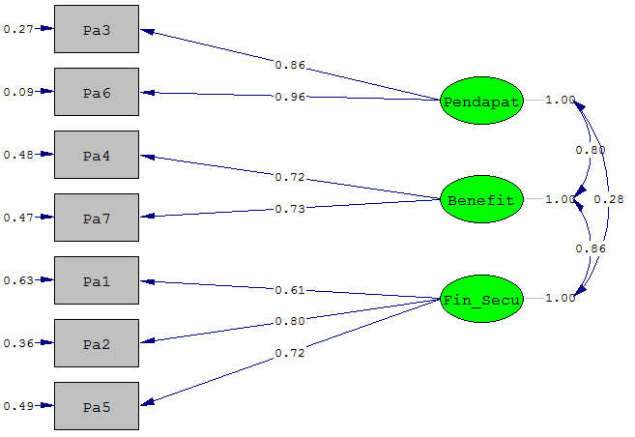

Output Tulisan:
Model CFA_Pa

Number of Iterations = 15

LISREL Estimates (Maximum Likelihood)

Measurement Equations

Pa3 = 0.857*Pendapat, Errorvar.= 0.266 , R² = 0.734
Standerr (0.0920) (0.0875)
Z-values 9.319 3.038
P-values 0.000 0.002

Pa6 = 0.956*Pendapat, Errorvar.= 0.0868 , R² = 0.913
Standerr (0.0899) (0.0990)
Z-values 10.632 0.877
P-values 0.000 0.381

Pa4 = 0.539*Benefit, Errorvar.= 0.710 , R² = 0.290
Standerr (0.114) (0.124)
Z-values 4.712 5.733
P-values 0.000 0.000

Pa7 = 0.541*Benefit, Errorvar.= 0.707 , R² = 0.293
Standerr (0.114) (0.124)
Z-values 4.726 5.711
P-values 0.000 0.000

Pa1 = 0.608*Fin_Secu, Errorvar.= 0.630 , R² = 0.370
Standerr (0.102) (0.106)
Z-values 5.970 5.947
P-values 0.000 0.000

Pa2 = 0.801*Fin_Secu, Errorvar.= 0.358 , R² = 0.642
Standerr (0.0982) (0.0994)
Z-values 8.160 3.604
P-values 0.000 0.000

Pa5 = 0.715*Fin_Secu, Errorvar.= 0.488 , R² = 0.512
Standerr (0.0995) (0.0990)
Z-values 7.192 4.931
P-values 0.000 0.000

Correlation Matrix of Independent Variables

Pendapat Benefit Fin_Secu
-------- -------- --------
Pendapat 1.000

Benefit 0.799 1.000
(0.130)
6.163

Fin_Secu 0.283 0.857 1.000
(0.110) (0.140)
2.574 6.135

Log-likelihood Values

Estimated Model Saturated Model
--------------- ---------------
Number of free parameters(t) 17 28
-2ln(L) 447.349 397.359
AIC (Akaike, 1974)* 481.349 453.359
BIC (Schwarz, 1978)* 525.637 526.303

*LISREL uses AIC= 2t - 2ln(L) and BIC = tln(N)- 2ln(L)

Goodness of Fit Statistics

Degrees of Freedom for (C1)-(C2) 11
Maximum Likelihood Ratio Chi-Square (C1) 12.770 (P = 0.3090)
Browne's (1984) ADF Chi-Square (C2_NT) 10.037 (P = 0.5270)
Estimated Non-centrality Parameter (NCP) 38.990
90 Percent Confidence Interval for NCP (20.701 ; 64.818)

Minimum Fit Function Value 0.500
Population Discrepancy Function Value (F0) 0.390
90 Percent Confidence Interval for F0 (0.207 ; 0.648)
Root Mean Square Error of Approximation (RMSEA) 0.048
90 Percent Confidence Interval for RMSEA (0.027 ; 0.064)
P-Value for Test of Close Fit (RMSEA < 0.05) 0.000

Expected Cross-Validation Index (ECVI) 0.840
90 Percent Confidence Interval for ECVI (0.657 ; 1.098)
ECVI for Saturated Model 0.560
ECVI for Independence Model 3.449

Chi-Square for Independence Model (11 df) 20.907

Normed Fit Index (NFI) 0.947
Non-Normed Fit Index (NNFI) 0.857
Parsimony Normed Fit Index (PNFI) 0.744
Comparative Fit Index (CFI) 0.933
Incremental Fit Index (IFI) 0.977
Relative Fit Index (RFI) 0.909

Critical N (CN) 49.967

Root Mean Square Residual (RMR) 0.033
Standardized RMR 0.033
Goodness of Fit Index (GFI) 0.946
Adjusted Goodness of Fit Index (AGFI) 0.910
Parsimony Goodness of Fit Index (PGFI) 0.848

- Model CFA Otonomi (Ot)
Model CFA awal:
Gambar Loading Faktor
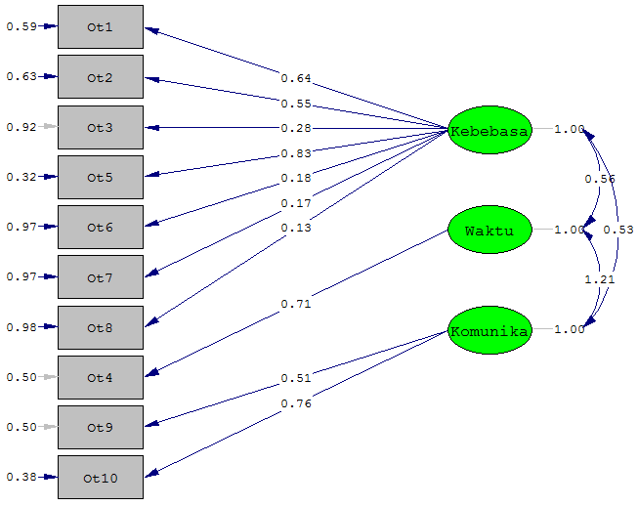
Output tulisan:
Model CFA_Otonomi Awal

Number of Iterations = 15

LISREL Estimates (Maximum Likelihood)

Measurement Equations

Ot1 = 0.644*Kebebasa, Errorvar.= 0.874 , R² = 0.0832
Standerr (0.110) (0.124)
Z-values 2.551 7.034
P-values 0.011 0.000

Ot2 = 0.551*Kebebasa, Errorvar.= 0.631 , R² = 0.325
Standerr (0.109) (0.115)
Z-values 5.035 5.509
P-values 0.000 0.000

Ot3 = 0.282*Kebebasa, Errorvar.= 0.600, R² = 0.409
Standerr (0.105)
Z-values 6.151
P-values 0.000

Ot5 = 0.825*Kebebasa, Errorvar.= 0.319 , R² = 0.681
Standerr (0.134) (0.181)
Z-values 6.168 1.764
P-values 0.000 0.078

Ot6 = 0.177*Kebebasa, Errorvar.= 0.969 , R² = 0.0315
Standerr (0.112) (0.138)
Z-values 1.590 7.010
P-values 0.112 0.000

Ot7 = 0.168*Kebebasa, Errorvar.= 0.972 , R² = 0.0281
Standerr (0.112) (0.139)
Z-values 1.503 7.017
P-values 0.133 0.000

Ot8 = 0.125*Kebebasa, Errorvar.= 0.984 , R² = 0.0157
Standerr (0.112) (0.140)
Z-values 1.120 7.041
P-values 0.263 0.000

Ot4 = 0.707*Waktu, Errorvar.= 0.500, R² = 0.500
Standerr (0.100)
Z-values 7.071
P-values 0.000

Ot9 = 0.506*Komunika, Errorvar.= 0.500, R² = 0.339
Standerr (0.0831)
Z-values 6.084
P-values 0.000

Ot10 = 0.759*Komunika, Errorvar.= 0.382 , R² = 0.601
Standerr (0.0914) (0.0915)
Z-values 8.297 4.171
P-values 0.000 0.000

Correlation Matrix of Independent Variables

Kebebasa Waktu Komunika
-------- -------- --------
Kebebasa 1.000

Waktu 0.320 1.000
(0.142)
2.259

Komunika 0.543 1.258 1.000
(0.111) (0.115)
4.909 10.938

Log-likelihood Values

Estimated Model Saturated Model
--------------- ---------------
Number of free parameters(t) 20 55
-2ln(L) 814.470 609.210
AIC (Akaike, 1974)* 854.470 719.210
BIC (Schwarz, 1978)* 906.574 862.495

*LISREL uses AIC= 2t - 2ln(L) and BIC = tln(N)- 2ln(L)

Goodness of Fit Statistics

Degrees of Freedom for (C1)-(C2) 9
Maximum Likelihood Ratio Chi-Square (C1) 56.054 (P = 0.0000)
Browne's (1984) ADF Chi-Square (C2_NT) 56.597 (P = 0.0000)
Estimated Non-centrality Parameter (NCP) 47.054
90 Percent Confidence Interval for NCP (27.074 ; 74.534)

Minimum Fit Function Value 0.561
Population Discrepancy Function Value (F0) 0.471
90 Percent Confidence Interval for F0 (0.271 ; 0.745)
Root Mean Square Error of Approximation (RMSEA) 0.229
90 Percent Confidence Interval for RMSEA (0.173 ; 0.288)
P-Value for Test of Close Fit (RMSEA < 0.05) 0.000

Expected Cross-Validation Index (ECVI) 0.801
90 Percent Confidence Interval for ECVI (0.601 ; 1.075)
ECVI for Saturated Model 0.420
ECVI for Independence Model 2.417

Chi-Square for Independence Model (15 df) 229.659

Normed Fit Index (NFI) 0.753
Non-Normed Fit Index (NNFI) 0.631
Parsimony Normed Fit Index (PNFI) 0.452
Comparative Fit Index (CFI) 0.778
Incremental Fit Index (IFI) 0.785
Relative Fit Index (RFI) 0.589

Critical N (CN) 39.266

Root Mean Square Residual (RMR) 0.123
Standardized RMR 0.132
Goodness of Fit Index (GFI) 0.848
Adjusted Goodness of Fit Index (AGFI) 0.645
Parsimony Goodness of Fit Index (PGFI) 0.363

Model CFA valid semua:
Gambar Loading Faktor
Output Tulisan:
Model CFA_Otonomi Valid

Number of Iterations = 13

LISREL Estimates (Maximum Likelihood)

Measurement Equations

Ot1 = 0.784*Kebebasa, Errorvar.= 0.385 , R² = 0.615
Standerr (0.0991) (0.100)
Z-values 7.913 3.834
P-values 0.000 0.000

Ot2 = 0.805*Kebebasa, Errorvar.= 0.500, R² = 0.564
Standerr (0.0979)
Z-values 8.222
P-values 0.000

Ot5 = 0.543*Kebebasa, Errorvar.= 0.706 , R² = 0.294
Standerr (0.105) (0.114)
Z-values 5.152 6.194
P-values 0.000 0.000

Ot4 = 0.757*Waktu, Errorvar.= 0.427, R² = 0.500
Standerr (0.100)
Z-values 7.071
P-values 0.000

Ot9 = 0.676*Komunika, Errorvar.= 0.543, R² = 0.356
Standerr (0.0861)
Z-values 6.105
P-values 0.000

Ot10 = 0.732*Komunika, Errorvar.= 0.465 , R² = 0.535
Standerr (0.0985) (0.0971)
Z-values 7.425 4.787
P-values 0.000 0.000

Correlation Matrix of Independent Variables

Kebebasa Waktu Komunika
-------- -------- --------
Kebebasa 1.000

Waktu 0.292 1.000
(0.153)
1.904

Komunika 0.507 1.259 1.000
(0.122) (0.115)
4.165 10.943

Log-likelihood Values

Estimated Model Saturated Model
--------------- ---------------
Number of free parameters(t) 12 21
-2ln(L) 431.572 375.517
AIC (Akaike, 1974)* 455.572 417.517
BIC (Schwarz, 1978)* 486.834 472.226

*LISREL uses AIC= 2t - 2ln(L) and BIC = tln(N)- 2ln(L)

Goodness of Fit Statistics

Degrees of Freedom for (C1)-(C2) 9
Maximum Likelihood Ratio Chi-Square (C1) 12.730 (P = 0.1750)
Browne's (1984) ADF Chi-Square (C2_NT) 16.597 (P = 0.0550)
Estimated Non-centrality Parameter (NCP) 47.054
90 Percent Confidence Interval for NCP (27.074 ; 74.534)

Minimum Fit Function Value 0.561
Population Discrepancy Function Value (F0) 0.471
90 Percent Confidence Interval for F0 (0.271 ; 0.745)
Root Mean Square Error of Approximation (RMSEA) 0.052
90 Percent Confidence Interval for RMSEA (0.037 ; 0.072)
P-Value for Test of Close Fit (RMSEA < 0.05) 0.000

Expected Cross-Validation Index (ECVI) 0.801
90 Percent Confidence Interval for ECVI (0.601 ; 1.075)
ECVI for Saturated Model 0.420
ECVI for Independence Model 2.417

Chi-Square for Independence Model (15 df) 22.659

Normed Fit Index (NFI) 0.853
Non-Normed Fit Index (NNFI) 0.831
Parsimony Normed Fit Index (PNFI) 0.752
Comparative Fit Index (CFI) 0.868
Incremental Fit Index (IFI) 0.885
Relative Fit Index (RFI) 0.789

Critical N (CN) 39.266

Root Mean Square Residual (RMR) 0.054
Standardized RMR 0.062
Goodness of Fit Index (GFI) 0.938
Adjusted Goodness of Fit Index (AGFI) 0.845
Parsimony Goodness of Fit Index (PGFI) 0.763

- Model CFA Tuntutan Kerja (BK)
Model CFA awal
Output Gambar Loading Faktor:
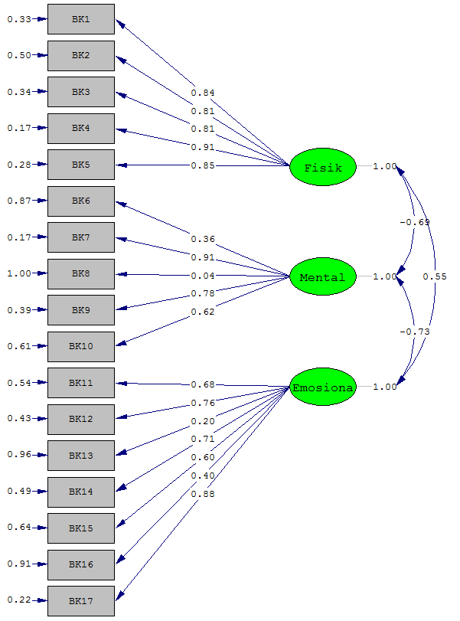
Output tulisan:
Model CFA_BK awal

Number of Iterations = 17

LISREL Estimates (Maximum Likelihood)

Measurement Equations

BK1 = 0.841*Fisik, Errorvar.= 0.325 , R² = 0.685
Standerr (0.0812) (0.0561)
Z-values 10.366 5.798
P-values 0.000 0.000

BK2 = 0.812*Fisik, Errorvar.= 0.499 , R² = 0.570
Standerr (0.0888) (0.0735)
Z-values 9.147 6.787
P-values 0.000 0.000

BK3 = 0.813*Fisik, Errorvar.= 0.339 , R² = 0.661
Standerr (0.0843) (0.0569)
Z-values 9.645 5.951
P-values 0.000 0.000

BK4 = 0.912*Fisik, Errorvar.= 0.169 , R² = 0.831
Standerr (0.0786) (0.0387)
Z-values 11.599 4.362
P-values 0.000 0.000

BK5 = 0.847*Fisik, Errorvar.= 0.282 , R² = 0.718
Standerr (0.0823) (0.0498)
Z-values 10.290 5.661
P-values 0.000 0.000

BK6 = 0.359*Mental, Errorvar.= 0.871 , R² = 0.129
Standerr (0.102) (0.126)
Z-values 3.509 6.917
P-values 0.000 0.000

BK7 = 0.913*Mental, Errorvar.= 0.167 , R² = 0.833
Standerr (0.0822) (0.0585)
Z-values 11.103 2.859
P-values 0.000 0.004

BK8 = 0.0366*Mental, Errorvar.= 0.999 , R² = 0.00134
Standerr (0.106) (0.142)
Z-values 0.345 7.035
P-values 0.730 0.000

BK9 = 0.779*Mental, Errorvar.= 0.393 , R² = 0.607
Standerr (0.0882) (0.0702)
Z-values 8.836 5.598
P-values 0.000 0.000

BK10 = 0.624*Mental, Errorvar.= 0.610 , R² = 0.390
Standerr (0.0947) (0.0939)
Z-values 6.593 6.498
P-values 0.000 0.000

BK11 = 0.677*Emosiona, Errorvar.= 0.541 , R² = 0.459
Standerr (0.0921) (0.0848)
Z-values 7.355 6.382
P-values 0.000 0.000

BK12 = 0.757*Emosiona, Errorvar.= 0.426 , R² = 0.574
Standerr (0.0884) (0.0713)
Z-values 8.567 5.983
P-values 0.000 0.000

BK13 = 0.195*Emosiona, Errorvar.= 0.962 , R² = 0.0381
Standerr (0.106) (0.137)
Z-values 1.842 6.998
P-values 0.065 0.000

BK14 = 0.714*Emosiona, Errorvar.= 0.492 , R² = 0.509
Standerr (0.0838) (0.0758)
Z-values 8.529 6.499
P-values 0.000 0.000

BK15 = 0.603*Emosiona, Errorvar.= 0.637 , R² = 0.363
Standerr (0.0951) (0.0965)
Z-values 6.340 6.598
P-values 0.000 0.000

BK16 = 0.404*Emosiona, Errorvar.= 0.912 , R² = 0.152
Standerr (0.0979) (0.132)
Z-values 4.131 6.901
P-values 0.000 0.000

BK17 = 0.882*Emosiona, Errorvar.= 0.222 , R² = 0.778
Standerr (0.0819) (0.0518)
Z-values 10.766 4.286
P-values 0.000 0.000

Error Covariance for BK3 and BK2 = 0.228
(0.0528)
4.313

Error Covariance for BK14 and BK2 = -0.238
(0.0475)
-5.016

Error Covariance for BK14 and BK13 = 0.294
(0.0705)
4.172

Correlation Matrix of Independent Variables

Fisik Mental Emosiona
-------- -------- --------
Fisik 1.000

Mental -0.700 1.000
(0.064)
-10.985

Emosiona 0.569 -0.732 1.000
(0.079) (0.062)
7.200 -11.893

Log-likelihood Values

Estimated Model Saturated Model
--------------- ---------------
Number of free parameters(t) 40 153
-2ln(L) 823.909 329.801
AIC (Akaike, 1974)* 903.909 635.801
BIC (Schwarz, 1978)* 1008.116 1034.392

*LISREL uses AIC= 2t - 2ln(L) and BIC = tln(N)- 2ln(L)

Goodness of Fit Statistics

Degrees of Freedom for (C1)-(C2) 87
Maximum Likelihood Ratio Chi-Square (C1) 349.144 (P = 0.0000)
Browne's (1984) ADF Chi-Square (C2_NT) 278.822 (P = 0.0000)
Estimated Non-centrality Parameter (NCP) 262.144
90 Percent Confidence Interval for NCP (208.368 ; 323.485)

Minimum Fit Function Value 3.491
Population Discrepancy Function Value (F0) 2.621
90 Percent Confidence Interval for F0 (2.084 ; 3.235)
Root Mean Square Error of Approximation (RMSEA) 0.174
90 Percent Confidence Interval for RMSEA (0.155 ; 0.193)
P-Value for Test of Close Fit (RMSEA < 0.05) 0.000

Expected Cross-Validation Index (ECVI) 4.151
90 Percent Confidence Interval for ECVI (3.614 ; 4.765)
ECVI for Saturated Model 2.400
ECVI for Independence Model 20.644

Chi-Square for Independence Model (105 df) 2034.382

Normed Fit Index (NFI) 0.827
Non-Normed Fit Index (NNFI) 0.834
Parsimony Normed Fit Index (PNFI) 0.685
Comparative Fit Index (CFI) 0.863
Incremental Fit Index (IFI) 0.864
Relative Fit Index (RFI) 0.791

Critical N (CN) 35.195

Root Mean Square Residual (RMR) 0.0975
Standardized RMR 0.0975
Goodness of Fit Index (GFI) 0.729
Adjusted Goodness of Fit Index (AGFI) 0.626
Parsimony Goodness of Fit Index (PGFI) 0.529

Model CFA valid semua:
Gambar Loading Faktor
Ouput tulisan:
Model CFA_BK valid

Number of Iterations = 18

LISREL Estimates (Maximum Likelihood)

Measurement Equations

BK1 = 0.835*Fisik, Errorvar.= 0.302 , R² = 0.698
Standerr (0.0826) (0.0520)
Z-values 10.109 5.810
P-values 0.000 0.000

BK2 = 0.796*Fisik, Errorvar.= 0.367 , R² = 0.633
Standerr (0.0847) (0.0598)
Z-values 9.392 6.132
P-values 0.000 0.000

BK3 = 0.847*Fisik, Errorvar.= 0.282 , R² = 0.718
Standerr (0.0820) (0.0497)
Z-values 10.339 5.678
P-values 0.000 0.000

BK4 = 0.881*Fisik, Errorvar.= 0.224 , R² = 0.776
Standerr (0.0800) (0.0433)
Z-values 11.013 5.167
P-values 0.000 0.000

BK5 = 0.841*Fisik, Errorvar.= 0.293 , R² = 0.707
Standerr (0.0823) (0.0510)
Z-values 10.210 5.754
P-values 0.000 0.000

BK6 = 0.554*Mental, Errorvar.= 0.875 , R² = 0.125
Standerr (0.102) (0.126)
Z-values 3.468 6.953
P-values 0.001 0.000

BK7 = 0.914*Mental, Errorvar.= 0.165 , R² = 0.835
Standerr (0.0821) (0.0602)
Z-values 11.124 2.738
P-values 0.000 0.006

BK9 = 0.779*Mental, Errorvar.= 0.394 , R² = 0.606
Standerr (0.0881) (0.0708)
Z-values 8.842 5.565
P-values 0.000 0.000

BK10 = 0.625*Mental, Errorvar.= 0.610 , R² = 0.390
Standerr (0.0943) (0.0936)
Z-values 6.625 6.513
P-values 0.000 0.000

BK11 = 0.717*Emosiona, Errorvar.= 0.486 , R² = 0.514
Standerr (0.0906) (0.0796)
Z-values 7.909 6.109
P-values 0.000 0.000

BK12 = 0.780*Emosiona, Errorvar.= 0.391 , R² = 0.609
Standerr (0.0876) (0.0694)
Z-values 8.904 5.642
P-values 0.000 0.000

BK14 = 0.737*Emosiona, Errorvar.= 0.457 , R² = 0.543
Standerr (0.0897) (0.0764)
Z-values 8.213 5.987
P-values 0.000 0.000

BK15 = 0.618*Emosiona, Errorvar.= 0.618 , R² = 0.382
Standerr (0.0948) (0.0949)
Z-values 6.518 6.513
P-values 0.000 0.000

BK16 = 0.534*Emosiona, Errorvar.= 0.888 , R² = 0.112
Standerr (0.103) (0.128)
Z-values 3.245 6.959
P-values 0.001 0.000

BK17 = 0.839*Emosiona, Errorvar.= 0.296 , R² = 0.704
Standerr (0.0846) (0.0605)
Z-values 9.917 4.886
P-values 0.000 0.000

Correlation Matrix of Independent Variables

Fisik Mental Emosiona
-------- -------- --------
Fisik 1.000

Mental -0.676 1.000
(0.066)
-10.241

Emosiona 0.590 -0.724 1.000
(0.076) (0.063)
7.729 -11.440

Log-likelihood Values

Estimated Model Saturated Model
--------------- ---------------
Number of free parameters(t) 33 120
-2ln(L) 694.539 345.395
AIC (Akaike, 1974)* 760.539 585.395
BIC (Schwarz, 1978)* 846.510 898.016

*LISREL uses AIC= 2t - 2ln(L) and BIC = tln(N)- 2ln(L)

Goodness of Fit Statistics

Degrees of Freedom for (C1)-(C2) 87
Maximum Likelihood Ratio Chi-Square (C1) 84.284 (P = 0.5630)
Browne's (1984) ADF Chi-Square (C2_NT) 88.822 (P = 0.4260)
Estimated Non-centrality Parameter (NCP) 262.144
90 Percent Confidence Interval for NCP (208.368 ; 323.485)

Minimum Fit Function Value 3.491
Population Discrepancy Function Value (F0) 2.621
90 Percent Confidence Interval for F0 (2.084 ; 3.235)
Root Mean Square Error of Approximation (RMSEA) 0.042
90 Percent Confidence Interval for RMSEA (0.025 ; 0.063)
P-Value for Test of Close Fit (RMSEA < 0.05) 0.000

Expected Cross-Validation Index (ECVI) 4.151
90 Percent Confidence Interval for ECVI (3.614 ; 4.765)
ECVI for Saturated Model 2.400
ECVI for Independence Model 20.644

Chi-Square for Independence Model (105 df) 104.382

Normed Fit Index (NFI) 0.927
Non-Normed Fit Index (NNFI) 0.934
Parsimony Normed Fit Index (PNFI) 0.885
Comparative Fit Index (CFI) 0.943
Incremental Fit Index (IFI) 0.964
Relative Fit Index (RFI) 0.891

Critical N (CN) 35.195

Root Mean Square Residual (RMR) 0.0345
Standardized RMR 0.0345
Goodness of Fit Index (GFI) 0.949
Adjusted Goodness of Fit Index (AGFI) 0.826
Parsimony Goodness of Fit Index (PGFI) 0.729

- Model CFA Kebermaknaan Kerja (KK)
Model CFA awal dan valid semua
Ouput Gambar Loading Faktor:
Output Tulisan:
Model CFA_KK awal dan valid

Number of Iterations = 21

LISREL Estimates (Maximum Likelihood)

Measurement Equations

KK1 = 0.840*PM, Errorvar.= 0.294 , R² = 0.706
Standerr (0.0833) (0.0552)
Z-values 10.088 5.333
P-values 0.000 0.000

KK2 = 0.959*PM, Errorvar.= 0.0806 , R² = 0.919
Standerr (0.0774) (0.0481)
Z-values 12.382 1.673
P-values 0.000 0.094

KK7 = 0.524*PM, Errorvar.= 0.895 , R² = 0.105
Standerr (0.100) (0.128)
Z-values 3.228 7.018
P-values 0.001 0.000

KK3 = 0.865*MM, Errorvar.= 0.252 , R² = 0.748
Standerr (0.0797) (0.0395)
Z-values 10.845 6.382
P-values 0.000 0.000

KK4 = 0.969*MM, Errorvar.= 0.0619 , R² = 0.938
Standerr (0.0733) (0.0184)
Z-values 13.206 3.366
P-values 0.000 0.001

KK5 = 0.927*MM, Errorvar.= 0.140 , R² = 0.860
Standerr (0.0761) (0.0264)
Z-values 12.191 5.297
P-values 0.000 0.000

KK8 = 0.944*MM, Errorvar.= 0.108 , R² = 0.892
Standerr (0.0749) (0.0224)
Z-values 12.603 4.818
P-values 0.000 0.000

KK6 = 0.901*GG, Errorvar.= 0.188 , R² = 0.812
Standerr (0.0781) (0.0349)
Z-values 11.544 5.368
P-values 0.000 0.000

KK9 = 0.901*GG, Errorvar.= 0.188 , R² = 0.812
Standerr (0.0781) (0.0350)
Z-values 11.533 5.379
P-values 0.000 0.000

KK10 = 0.836*GG, Errorvar.= 0.301 , R² = 0.699
Standerr (0.0819) (0.0486)
Z-values 10.211 6.200
P-values 0.000 0.000

Error Covariance for KK8 and KK5 = 0.0664
(0.0209)
3.172

Correlation Matrix of Independent Variables

PM MM GG
-------- -------- --------
PM 1.000

MM 0.769 1.000
(0.048)
15.990

GG -0.855 -0.936 1.000
(0.039) (0.020)
-22.153 -46.144

Log-likelihood Values

Estimated Model Saturated Model
--------------- ---------------
Number of free parameters(t) 24 55
-2ln(L) -103.960 -306.915
AIC (Akaike, 1974)* -55.960 -196.915
BIC (Schwarz, 1978)* 6.564 -53.631

*LISREL uses AIC= 2t - 2ln(L) and BIC = tln(N)- 2ln(L)

Goodness of Fit Statistics

Degrees of Freedom for (C1)-(C2) 31
Maximum Likelihood Ratio Chi-Square (C1) 36.124 (P = 0.242)
Browne's (1984) ADF Chi-Square (C2_NT) 37.910 (P = 0.183)
Estimated Non-centrality Parameter (NCP) 171.955
90 Percent Confidence Interval for NCP (130.605 ; 220.804)

Minimum Fit Function Value 2.030
Population Discrepancy Function Value (F0) 1.720
90 Percent Confidence Interval for F0 (1.306 ; 2.208)
Root Mean Square Error of Approximation (RMSEA) 0.042
90 Percent Confidence Interval for RMSEA (0.025 ; 0.067)
P-Value for Test of Close Fit (RMSEA < 0.05) 0.000

Expected Cross-Validation Index (ECVI) 2.510
90 Percent Confidence Interval for ECVI (2.096 ; 2.998)
ECVI for Saturated Model 1.100
ECVI for Independence Model 21.938

Chi-Square for Independence Model (45 df) 53.794

Normed Fit Index (NFI) 0.976
Non-Normed Fit Index (NNFI) 0.952
Parsimony Normed Fit Index (PNFI) 0.824
Comparative Fit Index (CFI) 0.958
Incremental Fit Index (IFI) 0.919
Relative Fit Index (RFI) 0.943

Critical N (CN) 26.460

Root Mean Square Residual (RMR) 0.0468
Standardized RMR 0.0468
Goodness of Fit Index (GFI) 0.960
Adjusted Goodness of Fit Index (AGFI) 0.874
Parsimony Goodness of Fit Index (PGFI) 0.728

