Outgroup residents attitude towards the existence of special Islamic housing
Hendro Prabowo (ndrahu@yahoo.com), Mahargyantari P. Dewi (mp_dewi@yahoo.co.id), Henny Regina Salve (alve_7@yahoo.com), Afmi Fuad (afmifuad@gmail.com)
Faculty of Psychology Gunadarma University, Depok

Abstract
Gated communities are normally presented in highly negative terms, based on the common assumption that they contribute to social segregation (Manzi & Bowers, 2005). In Jakarta, the upper class area of Menteng in Central Jakarta, which was originally inhabited by Dutch colonial rulers and later by the Chinese upper classes and their assistants from former president Soeharto (also residents), houses with high walls of up to four meters were the beginning of the gated community. Meanwhile, the development of Lippo Karawaci began in 1992, and then Bumi Serpong Damai in 1989 (Leisch, 2002). Today there has also been a growing upper class housing that is devoted to Muslims in Jakarta. One of them is Light Islamic Townhouse in East Jakarta. This case study examines the attitude of the out-group resident to the housing, where the out-group resident is the same neighborhood with the resident of the housing (living in the same Rukun Tetangga). With interviewed to 16 participants and did participant observation, the results show that middle class from the out-group resident consider the existence of the housing as closed, unwilling to blend, and exclusive. While the lower class from the out-group resident considered the existence of the housing to be positive and profitable because of cross subsidies. Practical and theoretical implications are discussed.

Keywords: attitude, out-group, gated community.

Introduction
According to James and Gail (1997), gated communities are residential areas with restricted access in which normally public spaces are privatized. They are security developments with designated perimeters, usually walls or fences, and controlled entrances that are intended to prevent penetration by nonresidents. They include new developments and older areas retrofitted with gates and fences, and they are found from the inner cities to the exurbs and from the richest neighborhoods to the poorest. Their gates range from elaborate two-story guardhouses staffed twenty-four hours a day to roll-back wrought-iron gates to simple electronic arms. Guardhouses are usually built with one lane for guests and visitors and a second lane for residents, who may open the gates with an electronic card, a code, or a remote control device. Some communities with round-the-clock security require all cars to pass the guard, issuing identification stickers for residents' cars. Others use video cameras to record the license plate numbers and sometimes the faces of all who pass through. Entrances without guards have intercom systems, some with video monitors, that residents may use to screen visitors.
Grant and Mittelsteadt (2004) define a gated community is a housing development on private roads closed to general traffic by a gate across the primary access. The developments may be surrounded by fences, walls, or other natural barriers that further limit public access. Atkinson and Blandy (2005) defined of the gated community as a housing development that restricts public access, usually through the use of gates, booms, walls and fences. Residential areas may also employ security staff or CCTV (closed-circuit television) systems to monitor access. They may include a variety of services such as shops or leisure facilities. These building enclosures are usually governed by legal and social frameworks that form the statutory conditions that residents have to comply with.
Blakely (2007) further defines gated communities as a residential areas with restricted access, such that spaces normally considered public have been privatized. Physical barriers – walled or fenced perimeters – and gated or guarded entrances control access. Gated communities include both new housing developments and older residential areas retrofitted with barricades and fences.

Types of gated community
Blakely and Snyder (1997) categorize gated community into three types: lifestyle communities, prestige communities, and security zone communities.

- Lifestyle communities
Lifestyle communities focus on leisure activities with recreational facilities, common amenities, and shared services at their core. Lifestyle enclaves may include retirement villages, golf communities, or suburban new towns. Developers hope to attract residents searching for identity, security, and a shared lifestyle with their neighbors. They seek to create a sense of community through common interests and activities. Lifestyle communities often feature golf courses or country clubs.
- Prestige communities
Prestige communities serve as symbols of wealth and status for image-conscious residents. Gates prevented the masses from seeing how the wealthy lived. Although these projects featured attractive settings, they did not often include common amenities or facilities.

- Security zone communities
Security zone communities close off public streets to nonresidents. They reflect a fear of outsiders who disrupt neighborhoods. Although developers put security in place in the other types of gated communities, in security zones the residents themselves may lobby for and participate in erecting the barriers. As urban problems overwhelm residents, they may request local authorities to close off streets or enclose neighborhoods to prevent outsiders from gaining access. Walls and gates are erected to deter crime, limit traffic, or maintain property values. Residents generally view gating their streets as a last resort to take back their community. The gates or other barricades are not seen as an amenity, but rather a necessity. These efforts are not without repercussions, as the patterns of movement, especially traffic, are altered to accommodate street closures. Although communities of all income levels have tried to use gating for neighborhood preservation, wealthy enclaves have proven most successful in achieving their goals of enclosure.

Negative term of gated community
Roitman (2010) elaborated subjective causes of the expansion of gated communities are considered as resulting from individuals’ desires, interests, viewpoints and opportunities. There are subjective causes: increased fear of crime, a search for a better lifestyle, desire for a sense of community, a search for social homogeneity, and aspirations for higher social status and social distinction within particular social groups. Edgü & Cimşit (2011) found that living in gated community in the context of smaller, limited settlement units, facilitates the social adaptation of the occupants that, improves social relations and consequently environmental satisfaction.
According to James and Gail (1997), the setting of boundaries is always a political act. Boundaries determine membership, someone must be inside and someone outside. Boundaries also create and delineate space to facilitate the activities and purposes of political, economic, and social life. So, the boundary in gated community can contribute to social segregation (Landman, 2000; Manzi & Bowers, 2005; Le Goix, 2005; Roitman, 2010), lack of opportunities for the poor to live in the city (Landman, 2000), stimulation of social tensions between the inside and outside, and the elaboration of ‘otherness’ as dangerous (Roitman, 2010).

Gate community in Indonesia
According to Grant & Mittelsteadt (2004), even the most extensively documented in the United States, gated communities are appearing in many countries, including Argentina, Australia, Bahamas, Brazil, Costa Rica, Indonesia, Latvia, Portugal, South Africa, Venezuela, Britain and Canada. In Indonesia, gated community are developed in Jakarta (Leisch, 2002), Bali (Hishiyama, 2010), Yogyakarta (Hartanto, 2016), Medan (Aulia, & Marpaung, 2017), and Depok (Hawley, 2017b).
Initially, gated community in Indonesia was developed at Menteng area in Central Jakarta, which was originally inhabited by Dutch colonial rulers and later by the Chinese upper classes and their assistants from former president Soeharto. And then, the development of Lippo Karawaci began in 1992, and Bumi Serpong Damai in 1989 (Leisch, 2002). In the last two years, there’s a deep fear about an increasing Islamic conservatism that moderates say is manifesting itself in a number of ways. Most recently there were mass protests on Jakarta’s streets led by hard-line Islamic groups opposed to the city's was jailed Christian Governor (Hawley, 2017a). This phenomenon is thought to affect the development of the gated community specifically for Muslims. Hawley (2017b) conducted an interview with one of the residents in a gated Muslim housing estate. She (the occupant) feels safe in the community, where Christians or any other faith are not welcome. “For me, because I am a Muslim, I am comfortable living here..…“It's easier to adapt here as we share the same belief, how should I say this? The homogenous community makes me feel comfortable.”
Today there are many housing estates known as Islamic housing or sharia housing, both low-cost housing and luxury housing, all of which are Sharia systems without usury, banks, seizures, and fines. Locations in Jakarta, Bogor, Depok, Tangerang, and Bekasi (Jabodetabek), as well as Bandung, Purwakarta, Cikampek, Sukabumi, Garut, and Ciamis (Indonesian Islamic Housing, 2019). However, the existence of this type of housing cannot be determined whether it is a gated community or not. This research was conducted in the East Jakarta area towards one of the upper class housing that is dedicated to Muslims in Jakarta, called Light Islamic Townhouse. Regarding the impact of social segregation of gated community, the research question is: What is the outgroup attitude of Light Islamic Townhouse to the existence of this special Islamic housing?

Method
The focus of this study was a four-week interview and observation at Light Islamic Townhouse. This Townhouse is located in the area of Rukun Tetangga (RT) 04 / Rukun Wilayah 08, Kelurahan Kelapa Dua Wetan, Ciracas Sub District, East Jakarta. Based on Blakely and Snyder (1997), the town house tends to a security zone communities. The RT 04 area has three types of settlements, namely: two townhouses for upper class residents, housing for middle class residents and kampung for lower class residents. Both townhouses are located in the east of the region.
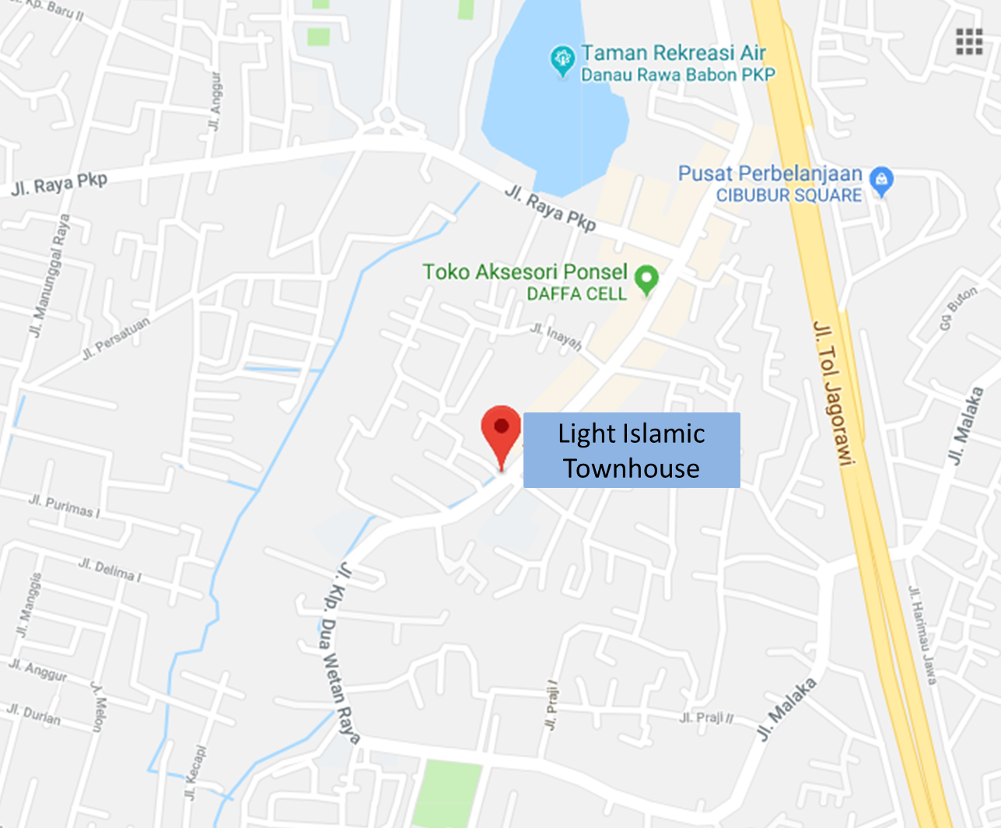
Figure 1. Map of the townhouse
Participants were 16 people from outgroups or residents outside the Light Islamic Townhouse (LIT), consists of 3 men and 13 women.These participants consist of residents who live in kampong (low class) and residents who live in housing (middle class). The researcher conducted interviews and observations of the research participants, and document of the LIT’s resident activity. So, the data collection matrix was presented in table 1. The two questions raised in this study are: What do you know about LIT? What do you think about LIT?

Table 1
Data collection matrix / Type of information from the source
Information/Information Source | Interviews | Observations | Document
Residents who live in kampong | Yes | Yes
Residents who live in housing | Yes
LIT’s resident activity |  |  | Yes

The data was analyzed manually through categorical aggregations (Creswell, 1998). The information and observation from each interview transcript were numbered in paragraphs, then grouped into some themes. The researcher subsequently grouped them into several categories based on these themes. Several categories are obtained from resident who live in kampong and resident who live in housing. In order to find several themes, these categories were arranged chronologically, which are exclusion, inclusion and positive perception. Finally, these categories and themes were written in a narrative including quotations and documentation results from participants.
Result

Exclusion
The theme of exclusion was obtained from participants living in housing or those from the middle class. LTI is a special Islamic housing, where residents do not want to join with residents from the same neighborhood (RT 04). The townhouse residents are upper class people who are busy and rarely at home, because only Sundays they are at home. They seemed closed because the houses were blocked by walls, so they did not know each other with people outside their housing. Three participants also claimed to not know of the existence of this townhouse. The occupants at LIT are also not careless in accepting guests, because they have to report to security. In addition, according to one participant, “Mothers cannot receive guests if they are not accompanied by their husbands”.
The participants generally also did not know what activities were carried out by the LIT residents, except that they had their own mosque, the mothers used the Syar'i veil and if the celebration of independence day they made their own program which was separated from other RT 04 residents. They also do not know how many units of the house and the number of residents. One participant hopes that the residents of LIT can blend with other residents. “It's okay, but if possible the neighbors will socialize, blend with other citizens.”
Activities carried out by residents of LIT are religious activities specifically for residents of LIT. The religious activities are in the form of I'tikaf, bi-weekly studies, hospitality (silaturahmi), and family gatherings.

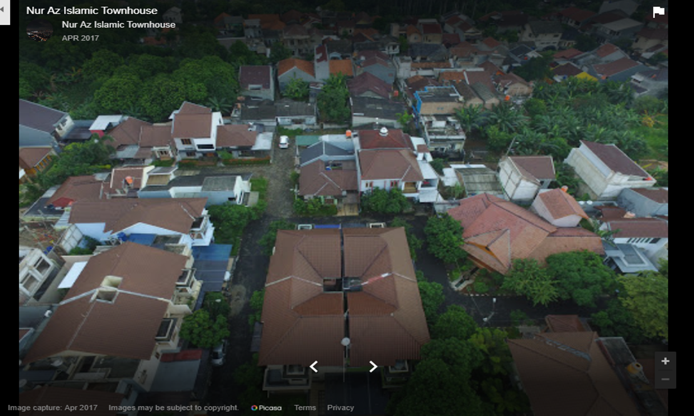
Figure 2. Perspective view of LIT

Inclusion
The existence of LIT is also inclusive in relation to religious activities. When performing fasting and Eid al-Adha celebrations, LIT residents participate directly and indirectly in the kampomg. One participant argued, “When religious celebrations in the fasting month or Eid al-Adha, they are involved in both their homes and kampong.” While other participants argued, “For Eid al-Adha, they gave a goat to a mosque on RT 04.”
For residents who live in kampong, the existence of LIT benefits them. They generally become gardeners, security, and maid servants, resulting in cross subsidies. It seems that they receive more than they should get, because there is additional zakat and ibadah Umrah if they are lucky. One participant said: “I always receive zakat every year from housing owners. Their gardeners can also get Umrah for free.”

Positive perception
Not all participants from housing have a negative perception of LIT. On the contrary, there are those who perceive as things in terms of comfort, neatness, cleanliness, beauty and security. This can also be a dream for them. One participant said: “As far as I know, LIT housing is comfortable, regularly organized Islamic housing ... and good. In my opinion, ... if there were funds for housing like that, LIT was my dream.” Another partisan said that LIT was. “Beautiful, cool, safe environment is also clean ...”.

Discussion
The existence of LIT as an Islamic gated community was apparently perceived as a safe environment for outgroups. This is also thought to be perceived by the resident. This supports the opinion of Roitman (2010) that subjective causes to to live in gated communities are reduce fear of crime, a search for a better lifestyle, desire for a sense of community, and a search for social homogeneity. However, with the exclusion and inclusion of residents to their outgroup, it is evident that this gated community does not necessarily result in social segregation (Landman, 2000; Manzi & Bowers, 2005; Le Goix, 2005; Roitman, 2010) and lack of opportunities for the poor to live in the city (Landman, 2000). The upper class community that runs Islam well is thought to be a factor that affects the inclusiveness of residents of the townhouse with other residents.
Social Identity Theory focuses on how group membership influences both one’s self-concept and one’s relations with in-group and out-group members (Tajfel & Turner, 1986). According to Hogg and Abram (1988) in a society, it consists of social categories which are classifications of people, including based on social class. Within each of this social categories is inherent a strength, status and dignity which ultimately gives rise to a distinctive social structure in society, namely a structure that determines the strength and status of relationships between individuals and between groups. Basically every individual wants to have a positive social identity. This is an effort to get recognition from other parties and social equality.
In fact, Laker (in Taylor & Moghaddam, 1994) found that in a situation where individuals or groups feel their identity as a member of a group is less valuable, there will be a phenomenon of misidentification, an effort to identify other identities / groups that are considered better. This can be found in some kampong and housing residents who tend to underestimate their own groups and prefer to identify residents of the townhouse.
In view of social identity theory, the desire to have a positive social identity is seen as an important psychological motor behind individual actions in every social interaction. This takes place through a social comparison process that is seen as a way to determine the position and status of social identity (Taylor & Moghaddam, 1994). The process of social comparison is a series of comparisons with other people / groups that subjectively help individuals make special judgments about their social identity compared to other social identities (Hogg & Abram, 1988).

Recommendation
This study provides recommendations for developers who will build Islamic housing that is of the type of gated community for the upper class to pay attention to the local resident from the lower classes and develop designs to increase interactions with local residents who also needed by gated community residents.

References
Atkinson, R., & Blandy, S. (2005). Introduction: International perspectives on the new enclavism and the rise of gated communities. Housing studies, 20(2), 177-186.
Atkinson, R., & Flint, J. (2004). Fortress UK? Gated communities, the spatial revolt of the elites and time–space trajectories of segregation. Housing studies, 19(6), 875-892.
Aulia, D. N., & Marpaung, B. O. (2017). Transformation of gated community in the last three decades in Medan City, Indonesia. IPTEK Journal of Proceedings Series, 3(3).
Bagaeen, S., & Uduku, O. (2010). Gated communities. Social sustainability in contemporary and historical gated developments. London: Earthscan.
Blakely, E. (2007). Gated communities for a frayed and afraid world. Housing Policy Debate 18(3), 475–480.
Blakely, E.J., & Snyder, M.G. (1997). Fortress America: Gated communities in the United States. Washington: The Brookings Institution.
Creswell, J. W. (1998). Qualitative inquiry and research design: Choosing among five traditions. Thousand Oaks, CA: Sage.
Edgü, E., & Cimşit, F. (2011). Island living as a gated community: Place attachment in an isolated environment. A| Z ITU Journal of the Faculty of Architecture, 8(2), 156-177.
Forrest, R., & Kearns, A. (2001). Social cohesion, social capital and the neighbourhood. Urban studies, 38(12), 2125-2143.
Grant, J., & Mittelsteadt, L. (2004). Types of gated communities. Environment and Planning B: Planning and Design, 31(6), 913-930.
Hartanto, T. (2016). Gated community, Studi Kasus: Perumahan Casa Grande di Yogyakarta. Teknik Sipil dan Arsitektur, 18(22).
Hawley, S. (2017a). Muslim-only gated housing booming in Indonesia http://www.abc.net.au/am/content/2016/s4706775.htm
Hawley, S. (2017b). Diversity concerns as gated Muslim communities in popularity in Indonesia. https://www.abc.net.au/news/2017-07-24/gated-muslim-communities-rising-popularity-in-indonesia/8736246.
Hishiyama, K. (2010). Uneasy society in Indonesia: With special attention to the gated community and CCTV in Bali. Procedia-Social and Behavioral Sciences, 2(1), 14-23.
Hogg, M.A., & Abram, D.(1988). Social identification: A social psychology of intergroup relation and group processes. London: Routledge.
Landman, K. (2000). Gated communities and urban sustainability: taking a closer look at the future.
Le Goix, R. (2005). Gated communities: Sprawl and social segregation in Southern California. Housing studies, 20(2), 323-343.
Leisch, H. (2002). Gated communities in Indonesia. Cities, 19(5), 341-350.
Manzi, T., & Smith-Bowers, B. (2005). Gated communities as club goods: Segregation or social cohesion?. Housing Studies, 20(2), 345-359.
Perumahan Islami Indonesia. (2019). Daftar perumahan islami – perumahan syariah Indonesia. http://www.perumahanislamiindonesia.com/p/daftar-lokasi.html.
Roitman, S. (2010). Gated communities: definitions, causes and consequences. Proceedings of the Institution of Civil Engineers: Urban Design and Planning, 163(1), 31-38.
Tafjel, H., & Turner, J. C. (1986). The social identity theory of intergroup behavior. Psychology of Intergroup Relations, 7-24.
Taylor, D.M., & Moghaddam, F.M.(1994). Theories of intergroup relations. London: Praeger.
Thuillier, G. (2005). Gated communities in the metropolitan area of Buenos Aires, Argentina: A challenge for town planning. Housing Studies, 20(2), 255-271.

