**Validation method of alkaloid determination from fermented endophytic fungi extract of *Phyllantus niruri* Linn with TLC densitometry**

**Sandra Dewi Tansil1, Eva Monica1, Yuyun Yuniati2, Leny Yuliati2, Rollando Rollando1\***

*1Program of Pharmacy, Faculty of Science and Technology, Ma Chung University, Malang*

*Jl. Villa Puncak Tidar N-01, Malang 6515*

*2Program of Chemistry, Faculty of Science and Technology, Ma Chung University, Malang*

*Jl. Villa Puncak Tidar N-01, Malang 65151*

***Submitted :........................ Reviewed :.......................... Accepted:.....................***

**ABSTRACT**

Endophytic fungi can produce compound that similar with the host, so it can be used as mass production of compound. The optimal and valid assay method is needed to obtain the proper culture condition, which one using densitometric Thin Layer Chromatography (TLC). This research used 11 samples of endophytic fungi culture extract from *Phyllantus niruri* within various culture condition. Optimization of mobile phase was done using 3 kinds of mobile phase mixture, mobile phase A, mobile phase B, and mobile phase C. Validation method measured using some parameters such as linearity, accuracy, and precision. The result of optimization and validation showed that TLC densitometry method can be used for measuring alkaloid level within the endophytic fungi extract of *Phyllantus niruri* using mobile phase C, with R value is 0.977, % recovery is between 90 – 110, and %RSD ≤ 7 on each concentration series. While the proper condition of endophytic fungi culture is using sucrose as carbon source and at pH 6 condition*.*

.

**Keywords**: *validation, phyllantus niruri, TLC densitometry, alkaloid*

***Corresponding author:***

Rollando Rollando

Program of Pharmacy, Faculty of Science and Technology, Ma Chung University, Malang

Jl. Villa Puncak Tidar N-01, Malang 6515

Email: [ro.llando@machung.ac.id](mailto:ro.llando@machung.ac.id)

**INTRODUCTION**

Endophytic fungi are fungi that colonize healthy plant tissue without causing symptoms or disease (Souza et al., 2011). This fungi can produce compounds that are similar, even identical to the compounds produced by the host (Selim et al., 2012). Almost all plants have endophytic fungi (Rodriguez et al., 2009). One example is the meniran plant (Phyllanthus niruri) with its endophytic fungi from the genus Fusarium. Meniran plants contain various compounds, some of which are lignans, glycosides, alkaloids, elagitanin, terpenes, and phenylpropanoids (Colpo et al., 2014).

The compounds contained in meniran plants have various pharmacological effects. Based on research conducted in mice, extracts from meniran plants can reduce blood sugar levels while protecting the pancreas with its antioxidant effects (Okoli et al., 2010). Other studies carried out using endophytic fungi Fusarium sp. from meniran plants showed antibacterial activity than diethyl ether fractions, antioxidants in 96% ethanol fraction, and cytotoxic effects on diethyl ether fractions (Rollando et al, 2017). The various pharmacological effects produced show the potential of meniran plants as anticancer, antibacterial and antidiabetic drugs.

The nature of endophytic fungi that are capable of producing compounds similar to their hosts provides an opportunity to produce massively active compounds. However, from the results of the study the results of extracts obtained from endophytic fungi were still very small. This is evident from the results of a study conducted by extracting 100 g of endophytic fungal mycelium Fusarium oxysporum from the leaves of Dysoxylum binectariferum with only 295.83 µg of extract (Kumara et al., 2014). The results of this small extract make it important to find a way to get the extract from endophytic fungi culture to the maximum.

The results of extracts from endophytic fungi can be obtained maximally if cultured using effective methods while maintaining their ability (Brian et al., 2015). Determination of the results of a optimum culture for the acquisition of the maximum compound can not be separated from the measurement of levels in the extract obtained. Determination of compound levels requires the right method to determine the level of the compound to be measured.

Thin layer chromatography densitometry is one method that can be used for quantitative analysis. Thin layer chromatography densitometry is a simple method that is suitable for analysis with large sample variations. In addition, the costs incurred by thin layer chromatography densitometry are less than those of HPLC. Based on research on qualitative and quantitative analysis of protopin on Fumaria sp. using the HPLC method and thin layer chromatography densitometry showed that thin layer chromatography densitometry was faster, cheaper, and easier to determine protopin levels than HPLC (Vrancheva et al., 2012).

The accuracy of a method in measuring levels can be determined by optimization and validation of the method used. Until now there is still no valid method for measuring alkaloid levels in endophytic fungi extracts of Fusarium sp. from Phyllanthus niruri Linn leaves. Therefore, research is needed on the optimization and validation of alkaloid content determination methods in Fusarium sp. Fungi extract culture. from Phyllanthus niruri Linn leaves. to get the right leveling method.

**MATERIALS AND METHOD**

**Materials**

The ingredients were endophyte fungi from Fusarium sp. genus, fungal growth media such as PDA (Potato Dextrose Agar), Column chromatography, chamber (Sigma), vacuum rotary evaporator (Junke & Kunkel), waterbath (labo-tech, Heraceus), eppendorf tubes, autoclave (AC-300AE, Tiyoda, Manufacturing Co. Ltd), aseptic box, petri dish (Pyrex), Linomat-5 Camag, TLC-3 Scanner Camag.

**Table I. Composition of mobile phase**

|  |  |  |  |  |
| --- | --- | --- | --- | --- |
| **Mobile Phase** | **chloroform** | **ethyl acetate** | **methanol** | **NH4OH** |
| A | 8 | 8 | 4 | - |
| B | 8 | 8 | 4 | 0,005 |
| C | 5 | 8 | - | 0,005 |

**Mobile phase optimization**

The mobile phase made with a mixture of chloroform, ethyl acetate, methanol and ammonium hydroxide with various comparisons such as in table I. The mobile phase is inserted in the chamber. Before being used for development, the mobile phase is saturated by shaking it in the chamber.

**Stock solution**

Stock solutions are made with isolated alkaloid compounds with a concentration of 2000 ppm. The solution is made by weighing 4 mg of alkaloid standard, then dissolved with methanol in a 2 ml microtube.

**Standard solution series**

The standard solution series is made in six types of concentration, 2000 ppm; 1800 ppm; 1600 ppm; 1400 ppm; 1200 ppm; 1000 ppm. The solution is made by dilution from the stock solution.

**Determination of the maximum wavelength**

Series standard solution spotted on the stationary phase and then developed with a mobile phase mixture. Development is done as high as 8 cm, then immediately dried and read absorbance at a wavelength of 200-800 nm wavelength range of 50 nm.

**Sample preparation**

Each extract of the sample obtained was dissolved with methanol with a concentration of 2000 ppm in a micro tube for the liquid to be bottled together with internal standard solutions.

**Mobile phase optimization**

The standard solution series that have been made are spotted in the stationary phase. Then developed in each mix of mobile phases. Development is done as high as 8 cm, and immediately dried to be measured at the maximum wavelength that has been obtained. The results of the development of samples from each mobile phase mixture compared to Rf and the chromatogram were standardized, then calculated the Asymmetry factor from the peak of the chromatogram obtained.

**Validation method**

**Specificity**

Sample and standard solutions are analyzed by the optimal method, the Rf data obtained is then compared.

**Linearity**  
 Linearity studies are carried out using the six standard solution series. Each standard solution was bottled on the same stationary phase plate (each concentration was replicated three times), then developed with the optimal mobile phase. The development results are then read at the maximum wavelength. The results of the peak area are plotted with the alkaloid levels obtained so that the calibration curve and regression equation are obtained.

**Accuracy**  
 Accuracy test is calculated as percent recovery from each standard solution concentration that has been measured for the calibration curve.

**Precision**  
 The precision test is calculated by percent RSD from each standard solution concentration that has been measured for the calibration curve.

**Measuring the levels of alkaloids in the sample**

The optimal and valid level determination method is carried out on each sample of fungi culture (0.3% salinity, 0.2% salinity; 1% carbon source from glucose, maltose, starch, sucrose, fructose; nitrogen source from NaNO3; and pH conditions 7, 6 and 5). After that the AUC results obtained are plotted in the equation of the calibration curve to calculate the alkaloid levels of each sample.

**Data Analysis**

Separation data from alkaloid in the extract would analyze with some parameters:

1. Choosing the most pointed peak of the chromatogram, then the results of the resolution of the peak are calculated using the equation described in the previous chapter.
2. Seeing the similarity of Rf from sample and standard.
3. Calculate the resolution of each mobile phase with the chromatogram peak of the alkaloid and other compounds beside it using the equation described in the previous chapter.
4. Calculate the correlation coefficient and percentage of recovery from concentration values obtained with 2 replications using the optimum mobile phase obtained.
5. Calculating the alkaloid levels in each sample using the calibration curve equation that has been obtained with Microsoft Excel.

**RESULTS AND DISCUSSION**

**Mobile phase optimization**

Optimization of separation in chromatography relates to the determination of the optimum conditions in separation. In Thin Layer Chromatography the most important thing in optimization is the selection of the mobile phase component. Determining the optimum mobile phase component can be measured through chromatographic response function, which is the resolution and asymmetry factor (As) (Snyder et al., 1997, cit. Hima, 2011) .Resolusi is one chromatographic response function that is widely used to measure the affinity between chromatogram peak. Separation between compounds is said to be perfect if the resolution obtained is more than 1.5 (Sastromahidjodjo, 2002, cit. Himawan, 2011). Asymmetry factor is a parameter to measure the sharpness of the peak produced in the chromatogram. According to Himawan (2011) an asymmetrical peak can produce inaccurate calculations, a decrease in the degree of resolution, and a peak exit time that is not reproducible. Symmetrical peaks are peaks that have As = 1, but the As value between 0.9 - 1.2 can still be said to optimum.

In the research conducted, mobile phase optimization is done by selecting one of the mobile phases of 3 types of mixtures, A, B, and C. The selection of the first mobile phase is done by comparing the results of separation of compounds under 366 nm UV light. Internal selection is used in the mobile phase selection, which is the result of the extract of meniran endophytic fungi from basal medium. Standard solution prepared at a concentration of 2000 ppm, then spotted the stationary phase. After drying, it is developed using all five mobile phase mixtures. The results of the development seen the separation under UV light 366 nm. From the results of elution, it can be seen that the best separation is obtained from the mobile phase C (chloroform: ethyl acetate: ammonium hydroxide = 5: 8: 0,005). This can be seen from the results of the stains of the alkaloid compounds produced with Rf 0.4 and the separation between the compounds that are optimum as in Figure 1.

After obtaining the best visual phase of mobile separation, the resolution and Asymmetry factor (As) were measured from the results of the densitogram. The measurement of the mobile phase C is compared with the mobile phases A and B. The results of the As calculation in the mobile phases A, B, and C are As for 5.3333; 0.8389; and 4,6667 in sequence. The As value obtained in each mobile phase is said to not meet the conditions that should be in the range 0.9 - 1.2. While the resolution measurement is obtained as in table II.

**Table II. Results of calculation of resolution**

|  |  |  |  |  |  |  |
| --- | --- | --- | --- | --- | --- | --- |
| **Mobile phase** | **replication** | **peak** | **To**  **peak** | **resolution** | **requirement** | **criteria** |
| A | 1 | 5 | left | 0,6000 | ≥1,5 | not |
| right | 5,1430 | yes |
| 2 | 4 | left | 0,6000 | not |
| right | 4,5330 | yes |
| 3 | 6 | left | 0,8990 | not |
| right | 4,3478 | yes |
| B | 1 | 8 | left | 1,3300 | not |
| right | 1,3850 | not |
| 2 | 8 | left | 1,2900 | not |
|  | right | 1,4600 | not |
|  | 3 | 6 | left | 1,7500 | yes |
| right | 1,5500 | yes |
| C | 1 | 2 | left | 0,6670 | not |
| right | 3,2700 | yes |
| 2 | 5 | left | 0,5450 | not |
| right | 2,0000 | yes |
| 3 | 2 | left | 0,5000 | not |
| right | 2,7500 | yes |

From the table data above it can be seen that in the mobile phase B the resolution criteria are met only on the third replication. In the mobile phase A the resolution criteria are met only on the right side of the peak alkaloid compound, as well as the mobile phase C. Although the results of the fulfillment of the resolution criteria and the movement phase A and C are the same, the mobile phase C is chosen because the KLT separation results are visually better under the lamp UV 366 nm.

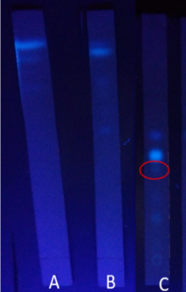

**Figure 1. The results of the elution of the three mobile phase mixtures on UV lamp 366**

**Determination of the maximum wavelength**

Measurements must be made at the maximum wavelength because the maximum wavelength of sensitivity is maximal so that the change in absorbance in each unit of concentration is greatest. In addition, at the maximum wavelength the shape of the absorbance curve is flat and complies with the Lambert-Beer law, and minimizes errors caused by re-installation of the wave length (Himawan, 2011).

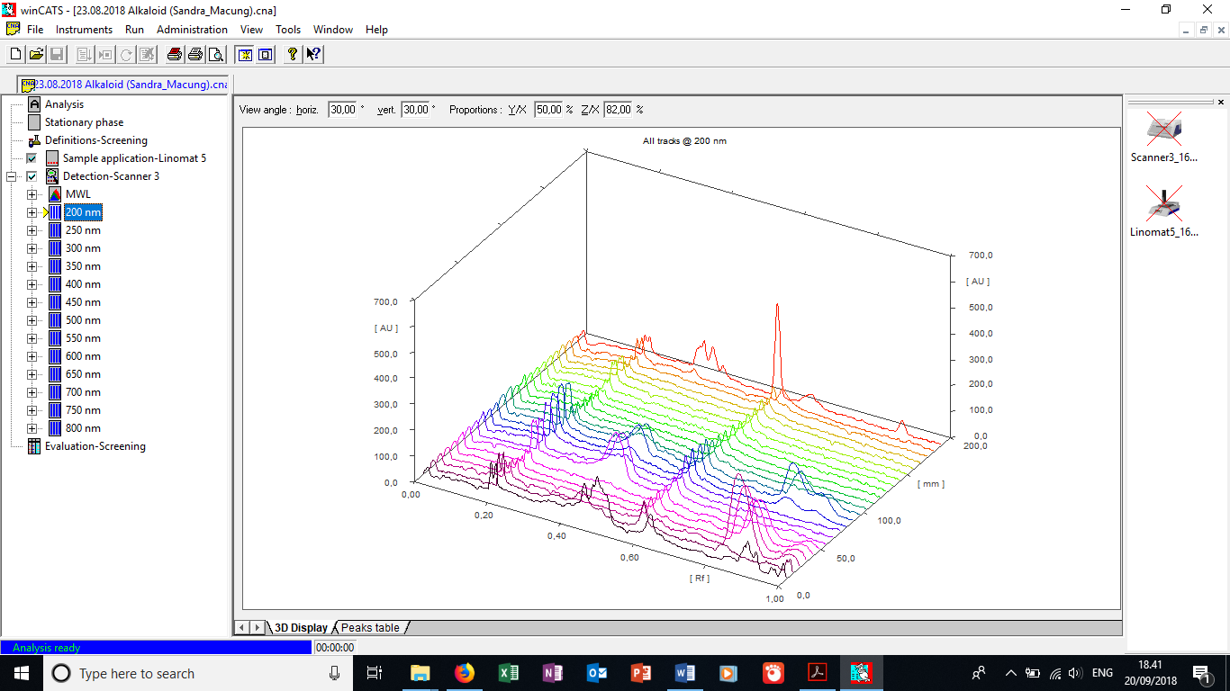

**Figure 2. Densitogram at a wavelength of 200 nm**

Determination of the maximum wavelength was carried out by measuring the standard solution and the other eleven samples at a concentration of 2000 ppm which was bottled on the TLC plate using Linomat 5 as much as 10 µL. Development is carried out using the C mobile phase, then readings at a wavelength of 200–800 nm with a range of 50 nm. The densitogram results from 13 wavelengths obtained are then compared to the peak gain. The maximum wavelength is obtained from the densitogram with the highest peak at Rf of about 0.4 which is the Rf of the alkaloid compound. Based on the densitogram obtained, the best peak densitogram results are at the 200 nm wavelength as in Figure 2, so the maximum wavelength is set at 200 nm.

**Linearity test**

Linearity tests are carried out to measure abilities within a certain range in obtaining test results that are proportional to the amount of concentration of analytes in the sample. In this study, the linearity test was carried out using a standard solution made into 6 types of concentrations, namely 2000 ppm, 1800 ppm, 1600 ppm, 1400 ppm, 1200 ppm, and 1000 ppm. Measurements were made with one replication, then the AUC results and calculated concentrations were averaged. The average results of calculated concentrations and AUC are plotted with the average concentration as the x axis and the average AUC as the y axis, so that the calibration curve is obtained as shown in figure 3.

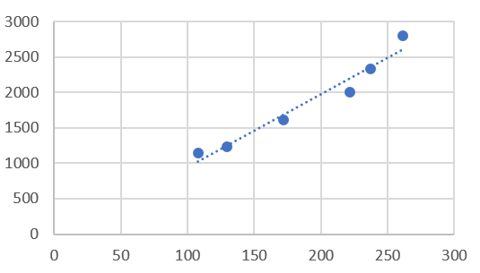

**Figure 3. Calibration curve**

Based on the results of the calibration curve, the equation y = 10.278x - 83.023, with R, slope, and intercept is 0.9769; 10,278; -83,023 in sequence. Based on the R results obtained, the linearity test can still be said to be fulfilling because the value of R is greater than the provisions of table R, with the requirements of table R being 0.9741 and the R linearity test obtained is 0.9769.

**Accuracy and precision test result**

Accuracy test is used to see the closeness between the received value as the reference value that has been received and the value obtained. In this study the reference value used is the standard solution of the basal medium and the value obtained comes from the sample with various media treatments. Accuracy in a method can be determined by percentage recovery.

In calculating accuracy, it is done by making 6 kinds of concentrations of bakus solution as in the linearity test. Each solution was bottled in the stationary phase with three replications, then the recovery percentage was calculated from each concentration series. The calculation results show the results of percentage recovery 98,3233; 105,7880; 102,1342; 98,5954; 95,6018; and 107.4840 at a solution concentration of 1000 ppm, 1200 ppm, 1400 ppm, 1600 ppm, 1800 ppm, and 2000 ppm respectively. Based on the requirements of AOAC in 2014, the accuracy test meets the requirements if the recovery percentage is in the range of 90 - 110. From the calculation results it can be seen that the accuracy test meets the requirements at all concentrations.

The precision test aims to show the closeness between the measurement series obtained from several partial drawings from one sample that is the same as the predetermined conditions. Precision analytical procedures can be determined based on the percentage of RSD. In this study precision repeatability tests, namely precision with the same operational conditions in a short period of time.

The precision test was carried out by calculating% RSD from the series of solution concentrations of the solution that was replicated twice. From the calculation obtained% RSD data of 1.5159; 5,1523; 4,6228; 3,3842; 2,8042; and 4.8294 from a solution concentration of 1000 ppm, 1200 ppm, 1400 ppm, 1600 ppm, 1800 ppm, and 2000 ppm respectively. Based on the requirements set by AOAC in 2014, namely ≤ 7, then from the calculation results at all concentrations meet the precision test.

**Determination of the level of alkaloids in the sample**

Carbon sources are used for normal growth fungi, especially glucose as an energy source to form primary metabolites. In fungi metabolism, carbon sources are an important component in Glutamine Synthetase (GS) which is the first step in the pathway for synthesis of important macromolecular compounds. In the stationary phase, when glucose has been used up for the formation of secondary metabolites, fungi will use other more complex carbon sources (Kavanagh, 2005).

In its use, although glucose is the best carbon source for microbial growth, it is rarely used in the formation of secondary metabolites. Glucose can inhibit several syntheses of secondary metabolites, one of which is ergot alkaloids. In the formation of secondary metabolites, for example in beta lactam, a fast-used carbon source (glucose, maltose, fructose) produces less beta lactam compared to slow used sugar (sucrose, galactose) (Drew and Demain, 1977).

Complex carbon sources such as starch in metabolism will be broken down into simpler sugars by the enzyme α-amylase to maltose to glucose. The glucose produced will experience glycolysis to pyruvate and enter the krebs cycle. This oxaloacetate produced by the krebs cycle is later converted into various amino acids which are precursors in the biosynthesis of alkaloid compounds.

In samples with carbon sources, the highest levels of alkaloid were obtained in starch samples followed by sucrose samples with amounts that were not much different (Figure 4). High levels of alkaloid in starch and sucrose samples can be obtained because both are slow used sugar with a more complex structure than other carbon sources used.

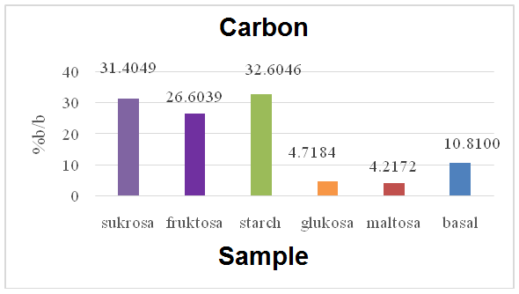

**Figure 4. Diagram of carbon source samples**

The pH condition of the medium is a factor for determining the metabolism and biosynthesis of secondary metabolites. This is because pH is related to the permeability of walls and cell membranes, so that it can affect the entry and exit of ions from medium nutrients (Merlin et al., 2013).

In indole alkaloids namely slaframine and swainsonin produced by Rhizoctonia leguminicola derived from biosynthesis of pipekolat acid which is a derivative of L-lysine. In the biosynthesis of pipekolat acid it involves the enzyme saccharopine oxidase in sequence: L-lysine → saccharopine → 1-piperidein-6-carboxylic acid → pipekolat acid. According to research that has been done, the enzyme saccharopine oxidase has the most optimum activity at pH 6 (Wickwire et al., 1990).

For samples in various treatments the pH results of most alkaloids were obtained at pH 6. In the diagram results (Figure 5) showed an increase in the amount of alkaloid content at pH 6 compared to the basal medium. This can occur due to the optimum activity of the enzyme saccharopine oxidase in the synthesis of alkaloids at pH 6. In addition, the growth of a good endophytic fungus will certainly affect the results of secondary metabolites. According to Ramadhani (2017) Fusarium sp. can grow well at pH 4.5-6. The optimum pH 6 condition for the growth of fungi and the production of the enzyme saccharopine oxidase which makes alkaloid levels in samples with a pH of 6 higher than the basal medium.

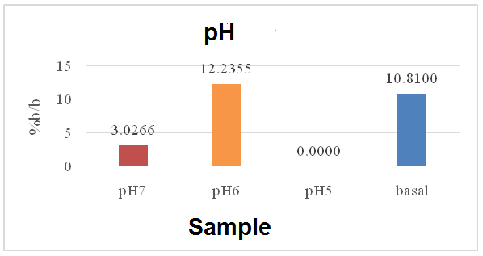

**Figure 5. Sample diagram of pH treatment**

Salinity is one of the environmental factors that can affect the results of endophytic secondary metabolites, because the habitat of the host endophytic fungi affects the salinity concentration needed. In endophytic fungi with hosts whose habitat is in the sea tends to require higher salinity compared to fungi whose hosts live in the soil (Mathan et al., 2013). Along with increasing salinity levels, the cytoplasm in the cell wall will increase (Allakhverdiev et al., 2000). The decreased intracellular salinity makes the condition become hypotonic so that water enters the plasma membrane. Conversely, in a hypertonic state with an increase in salinity levels, the water will come out of the plasma membrane so that the cell shrinks and the cell metabolites are inactive (Pratiwi, 2008).

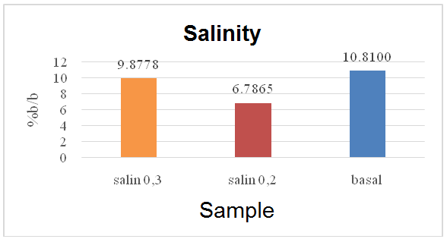

**Figure 7. Diagram of salinity**

In samples with differences in salinity concentration the highest alkaloid content was obtained at salinity of 0.3%. Compared with the acquisition of alkaloids from the basal medium, the treatment of salinity samples that have been carried out produces fewer alkaloids (Figure 7). According to Merlin et al. (2013) the addition of concentrations of secondary metabolites continued to increase with increasing NaCl to a concentration of 3%, and began to decrease at a concentration of 3.5%. In this study the alkaloid levels in salinity samples were no more than basal medium due to a lack of high salinity levels during fermentation which made endophytic fungi produce more nonpolar compounds.

In addition to carbon sources, nitrogen sources are also used for cell growth at the beginning of fermentation. At the end of cell growth, nitrogen is used to form secondary metabolites through enzymatic reactions and metabolic processes (Stanbury and Whitaker, 1984). Nitrogen and carbon play an important role in glutamate synthesis which is used as the initial pathway for synthesis of macromolecular compounds in fungi (Kavanagh, 2005).

Almost all alkaloids are derivatives of amino acids. In alkaloid biosynthesis of amino acids using aliphatic nitrogen requires the formation of heterocyclic rings followed by the synthesis of new C-N bonds (Luckner, 1984). Alkaloids can be produced by forming acid-amide bonds in the presence of carbonyl groups as in the reaction below.

R1CO-X + H2NR2 → R1CO-NHR2 + X-H

The sample with the addition of a nitrogen source from NaNO3 showed a decrease in the number of alkaloids obtained when compared to basal media (Figure 8). Based on the reaction described above, there is no increase in alkaloid levels in nitrogen samples due to the absence of carbonyl groups which help to form acid-amide bonds, so that heterocyclic rings cannot form.

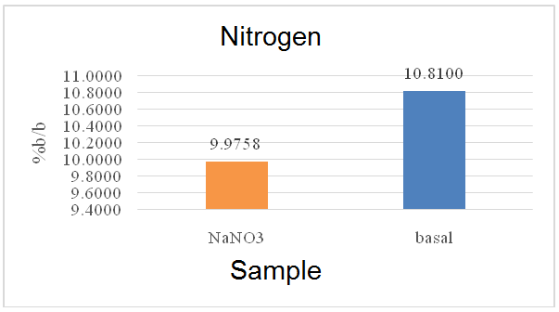

**Figure 8. Diagram of a nitrogen source sample**

**CONCLUSION**

1. The most optimal mobile phase in separating compounds from extracts from fermented endophytic fungi of meniran is a mixture of mobile phase C consisting of chloroform: ethyl acetate: ammonium hydroxide (5: 8: 0,005).
2. TLC densitometry can be used as a method of measuring the alkaloid levels of extracts from fermented endophytic plants of valid meniran by fulfilling several requirements of validity parameters including linearity with R = 0.977, accuracy with% recovery between 90-100 in each concentration series, and% RSD ≤ 7 in each concentration series.
3. The results of measuring the alkaloid levels in the sample show that the good conditions for the culture of endophytic fungi of meniran to obtain maximum alkaloid levels are with carbon sources from starch and at pH 6 conditions.

**ACKNOWLEDGEMENT**

The authors are grateful to the Directorate General of Strengthening Research and Development, Ministry of Research,Technology and Higher Education of the Republic of Indonesia via the Higher Education ExcellentBasic Research (PDUPT 2018, No. 3/E/KPT/ 2018 and No. 004/ MACHUNG/LPPM/ SP2H-LIT/II/2018.

**REFERENCES**

Alurappa, R., et al. 2018, *Microbial Biotechnology*, 1st Edition, Springer, Singapore.

Amna, T. et al. 2012, Effect of precursors feeding and manipulation on production of novel anticancer pro-drug camptothecin from endophytic fungus, *Brazilian Journal of Microbiology*, 1476-1489.

AOAC. 2014, ‘A 2014 Overview’, AOAC International.

Blankenship, J.D. et al. 2001, Production of loline alkaloids by the grass endophyte, *Neotyphodium uncinatum*, in defined media, *Phytochemistry*, **58**:395-401.

Colpo, E., Vilanova, C.D.D.A., Pereira, R.P., Reetz, L.G.B., Oliveira, L., Farias, I.L.G., Boligon, A.A., Athayde, M.L., Rocha, J.B.T. 2014, Antioxidant effects of *Phyllanthus niruri* tea on healthy subjects, *Asian Pac. J. Trop. Med.* **7**:113–118.

de Souza, J.J., Vieira, I.J.C., Rodrigues-Filho, E., and Braz-Filho, R. 2011, Terpenoid from Endophytic Fungi, *Molecules*, **16**:10604–10618.

Deinstrop, E.H. 2007, Applied Thin-Layer Chromatography 2nd Edition, translated from German by R. G. Leach, Wiley-VCH.

Dolowy, M. et al. 2015, A Validated Densitometric Method for the Determination of Mesterolone in Bulk Material and in Tablets, *Biomed Research International*, **2015**:1-8.

Drew, S.W. and Demain, A.L. 1977, Effect of primary metabolites on secondary metabolism, *Annu. Rev. Microbiol,***31**:343-356.

Girges, M.A. et al. 2013, High performance liquid chromatography, TLC densitometry, firstderivative and first-derivative ratio spectrophotometry for determination of rivaroxaban and its alkaline degradatesin bulk powder and its tablets, *Journal of Chromatography and Separation Techniques*, **4(8)**:1-6.

Facchini, P.J. 2001, Alkaloid Biosynthesis in Plants : Biochemistr, Cell Biology, Molecular Regulation, and Metabolic Engineering Aplications, *Annu. Rev. Plant Physiol. Plant Mol. Biol.*, **52**:29-66.

Hamayun, M., Hussain, A., Khan, S.A., Kim, H.Y., Khan, A.L., Waqas, M., Irshad M., Iqbal A., Rehman G., Jan, S. and Lee, I.J. 2017. Gibberellins producing endophytic fungus *Porostereum spadiceum* AGH786 rescues growth of salt affected soybean, *Frontiers in Microbiology*, 8.

Himawan, D.E. 2011, ‘Optimasi Penetapan Kadar Kurkumin Dalam Sediaan Cair Obat Herbal Terstandar (OHT) Merk “Kiranti®” Dengan Metode Kromatografi Lapis Tipis (KLT)-Densitometri’, *skripsi*, S. Farm, Fakultas Farmasi, Universitas Sanata Dharma.

Hyde, K.D and Soytong, K. 2008, The fungal endophyte dilemma, *Fungal Diver*sity **33(1)**:163–173.

ICH. 2005, *Validation of Analytical Procedures : Text and Methodology*, Internal Conference of Harmonisation of Technical Requirements for Registrasion of Pharmaceutical for Human Use.

Kar, A. 2007, *Pharmacognosy and Pharmacobiotechnology*, 2nd Edition, New Aged International Publisher, New Delhi, India.

Kaur, N. et al. 2017, Phytochemistry and pharmacology of *Phyllantus niruri* L. : a review, *Phytotherapy Research*.

Kavanagh, K. 2005, Fungi: Biology and Applications. John Wiley & Sons.

Kumara, P.M., Soujanya, K.N., Ravikanth, G., Vasudeva, R., Ganeshaiah, K.N. and haanker, R.U. 2014, Rohitukine, a chromone alkaloid and a precursor of flavopiridol, is produced by endophytic fungi isolated from *Dysoxylum binectariferum* Hook.f and *Amoora rohituka* (Roxb), *Phytomedicine,* **21**:541–546.

Kusari, S., & Spiteller, M. 2012, Metabolomics of endophytic fungi producing associated plant secondary metabolites: progress, challenges and opportunities, *Institute of Environmental Research (INFU) of the Faculty of Chemistry, Chair of Environmental Chemistry and Analytical Chemistry, TU Dortmund, Dortmund*, 241-266.

Luckner, M. 1984, *Secondary Metabolism in Microorganism, Plants, and Animals*, 2nd Edition, Springer-Verlag Berlin Heidelberg.

Martinuz, A., Schouten, A. & Sikora, R.A. 2013, Post-infection development of *Meloidogyne* incognita on tomato treated with the endophytes *Fusarium oxysporum* strain Fo162 and *Rhizobium etli* strain G12, *BioControl,* **58**:95–104.

Mathan, S., Subramanian, V., dan Nagamony, S. 2013, Optimization and antimicrobial metabolite production from endophytic fungi Athelia rolfsii KC 582297,*European Journal of Experimental Biology*, **3**: 138–144.

Merlin, J.N. et al. 2013, Optimation of growth and bioactive metabolite production :*Fusarium solani*, *Asian journal of pharmaceutical and clinical research*, **6**:98-103.

Okoli, C.O. et al. 2010, Evaluation of antidiabetic potentials of Phyllanthus niruri in alloxan diabetic rats, *Afr J Biotech-nol*, **9**: 248–259.

Porras-Alfaro, A., and Bayman, P. 2011, Hiddenfungi, emergentproperties: endophytes and microbiomes, *Annu. Rev.Phytopathol,* **49**,:291–315.

Pratiwi, S.T. 2008,*Mikrobiologi Farmasi*, Erlangga Medical Series.

Ramadhani, S.H. et al. 2017, Isolasi dan identifikasi jamur endofit pada daun jamblang (*Syzigium cumini* L), *Jurnal Ilmiah Mahasiswa Fakultas Keguruan dan Ilmu Pendidikan Unsyiah,* **2(2)**:77-90.

Rasmussen, S. et al. 2006, High nitrogen supply and carbohydrate content reduce fungal endophyte and alkaloid concentration in *Lolium perenne*, *Newphytologist*, **173**:787-797.

Richards, T.A., Soanes, D.M., Foster, P.G., Leonard, G., Thornton, C.R., and Talbot, N.J. 2009, Phylogenomic analysis demonstrates a pattern of rare and ancient horizontal gene transfer between plants and fungi, *The Plant Cell*, **21**: 1897-1911.

Rodriguez, R.J., White, Jr.J.F., Arnold, A.E. and Redman, R.S. 2009. Fungal endophytes: diversity and functional roles, *New Phytolology*, **182**: 314–330.

Rollando, et al. 2017, Kajian aktivitas antibakteri, antioksidan, dan sitotoksik fungi endofit genus *Fusarium sp.* isolat daun meniran (*Phyllantus niruri* Linn.), *Pharmaciana*, **7**:95-104.

Selim, K. A., El-Beih, A. A., Abdel-Rahman, T. M., dan El-Diwany, A. I. 2012, Biology of endophytic fungi, *Curr. Res. Environ. Appl. Mycol*, **2(1)**:31-38.

Selosse, M.A. Dubois, M.P., & Alvarez, N. 2009, Do Sebacinales commonly associate with plant roots as endophytes, *Mycological Research*. **113**:1062-1069.

Sherma, J. and Fried B. 2003, *Handbook of Thin-Layer Chromatography*, 3rd Edition, Marcel Dekker, Inc., New York, America.

Smolyanyuk, E.V. et al. 2013, Effect of sodium chloride concentration in the medium on the composition of the membrane lipids and carbohydrates in the cytosol of the fungus *Fusarium* sp., *Microbiology*, **82(5)**:600-608.

Stanbury, P.F. and Whitaker, A. 1984,*Principles of Fermentation Technology*, 1st Ed. edition. ed. Pergamon, Oxford Oxfordshire, New York.

Tang, Z. et al. 2011, Effects of endophytic fungus and its elicitors on cell status and alkaloid synthesis in cell suspension cultures of *Catharanthus roseus*, *ajournal of Medicinal Plants Research*, **5**(11):2192-2200.

Venieraki, A. et al. 2017, Endophytic fungi residing in medical plants have the ability to produce the same or similaar pharmacologically active secondary metabolites as their host, *Hellenic Plant Protection Journal*, **10**:51-66.

Vrancheva, R. Et al. 2012, Qualitative and Quantitative Determinationof Protopine in *Fumaria spp.* By TLC Densitometry Method, *J. Bio Sci. Biotech.*, **1(3)**:255-259.

Wang, Y. et al. 2011, Effects of high salt stredd on secondary metabolite production in the marine-derived fungus *Spicaria elegans*, *Marines Drugs*, **9**:535-542.

Wickwire, B.M. et al. 1990, Pipecolic acid biosynthesis in *Rhizoctonia leguminicola*, *The Journal of Biological Chemistry,***265(25)**:14748-14753.

Zhao, J., Shan, T., Mou, Y. and Zhou, L. 2011, Plantderived bioactive compounds produced by endophytic fungi, *Mini reviews in medicinal chemistry*, **11**: 159-168.

zum Felde, A., Mendoza, A., Cabrera, J.A., Kurtz, A., Schouten, A., Pocasangre, L., & Sikora, R. A. 2009, The burrowing nematode of banana: Strategies for controlling theuncontrollable. In Jones, D. & Van den Bergh, I. (Eds.), *Proceeding of InternationalSymposium on Banana Crop Prot. Sust. Prod. & Impr. Livelihood. Acta Horticulturae*, **828**:101-108.